Synthesis, Molecular modeling study, and biological evaluation of N-Acyl-anthranoylanthranilic acid Derivatives and Their Cyclized Benzoxazinones as Novel HIV-1 Nonnucleoside Reverse Transcriptase Inhibitors

H. M. Abdel-Aziz^{a,b}, A. M. Aliª, A. A-M. Abdel-Hafezª and A. F. Youssef *ª

ª Department of Medicinal Chemistry, Faculty of Pharmacy, Assiut University, Assiut, 71526, Egypt.
^{b} Present affiliation, Department of Medicinal Chemistry, Faculty of Pharmacy, South Valley University, Qena, 83511, Egypt.

Electronic Supplementary Material

Table S1. 2D illustration of NNIBP-ligand interaction forces, the binding energy score ΔG, and IC₅₀ values.
2D representation of the interactions | distance | Receptor- Ligand  Binding  Force | Receptor  Amino  Acid  residues | ΔG  Kcal/mole | IC₅₀ | Compound
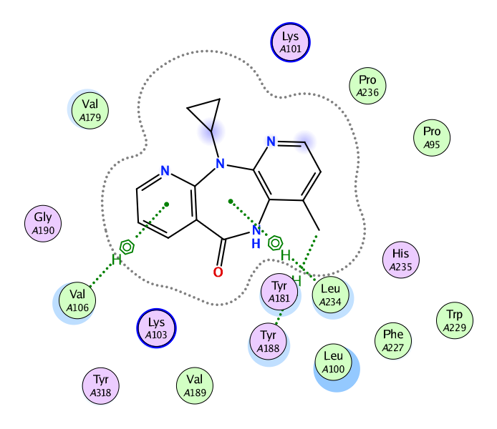 | 3.98  4.25  4.43 | H - π  H - π  H - π | Val106  Try188  Leu234 | -7.59 | 0.11 | Nevirapine
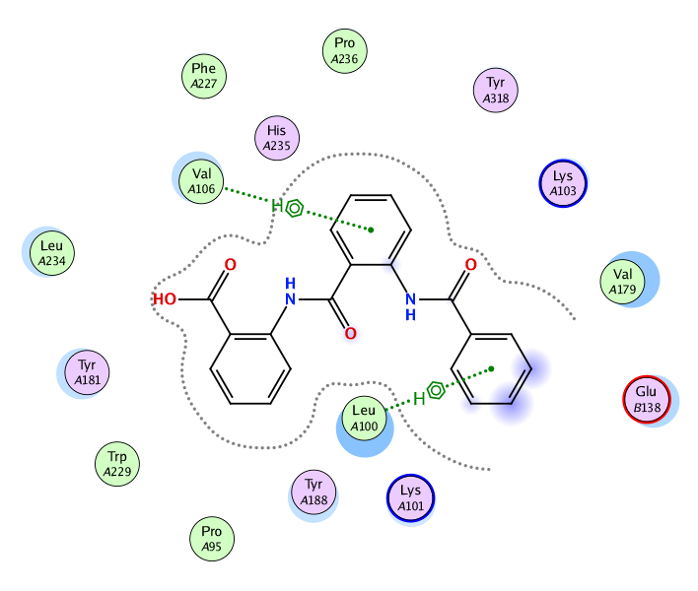 | 4.48  3.94 | H - π  H - π | Leu100  Val106 | -8.57 | 0.37 | 5a
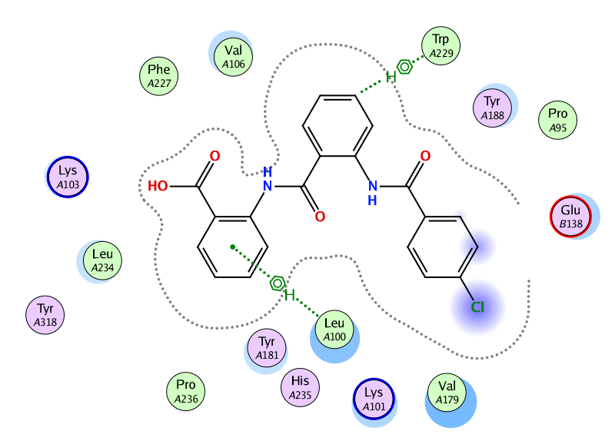 | 4.47  4.22 | H - π  H - π | Leu100  Trp229 | -8.59 | 1.37 | 5b

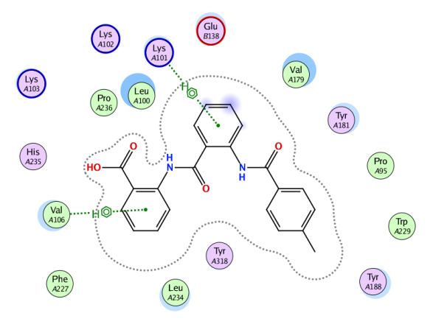 | 4.66  4.03 | H - π  H - π | Lys101  Val106 | -8.63 | 0.37 | 5c
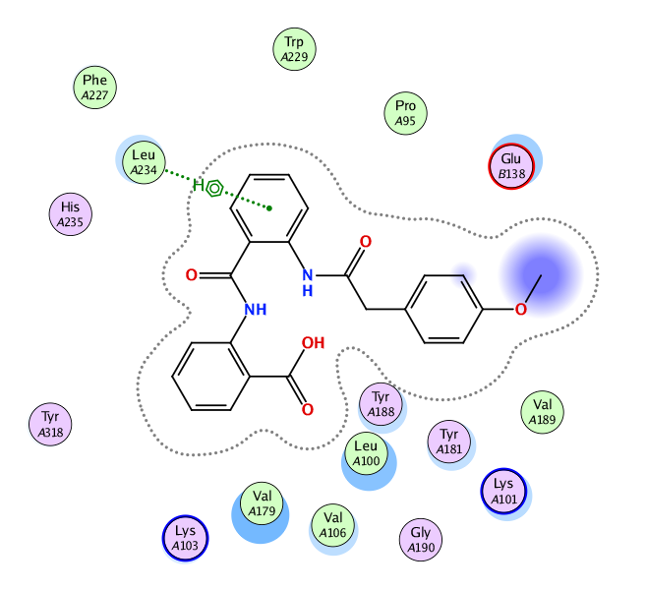 | 4.25 | H - π | Leu234 | -8.95 | 1.35 | 5d
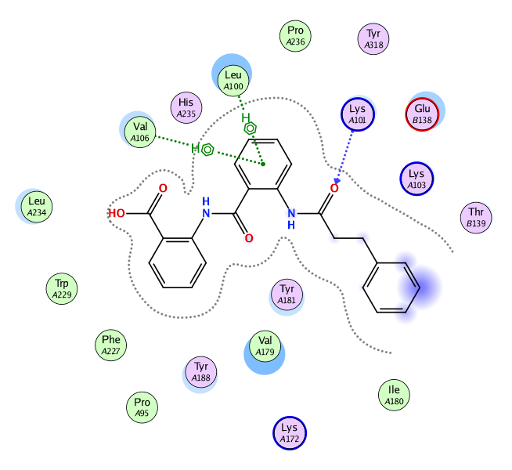 | 4.25  3.25  3.82 | H - π  H - π  H - π | Leu100  Lys101  Val106 | -9.03 | 123.52 | 5e

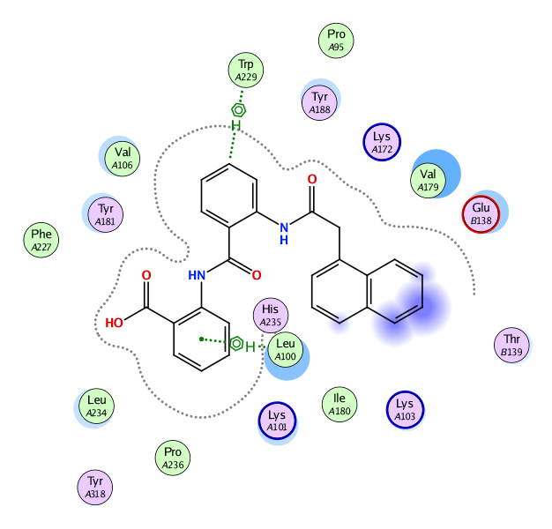 | 4.41  4.2 | H - π  H- π | Leu100  Trp229 | -8.74 | 17.73 | 5f
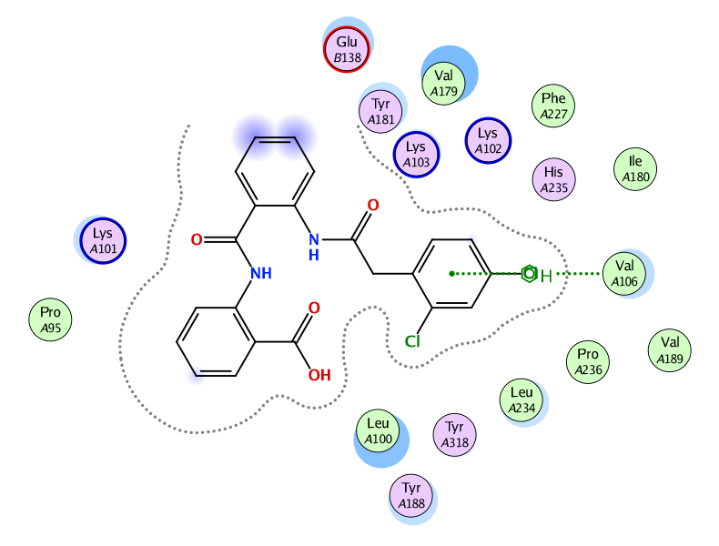 | 3.91 | H - π | Val106 | -8.17 | 4.76 | 5g
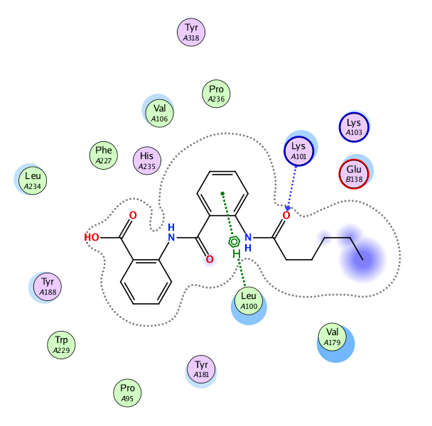 | 4.38  2.91 | H - π  H - π | Leu100  Lys101 | -8.06 | 5.1 | 5h

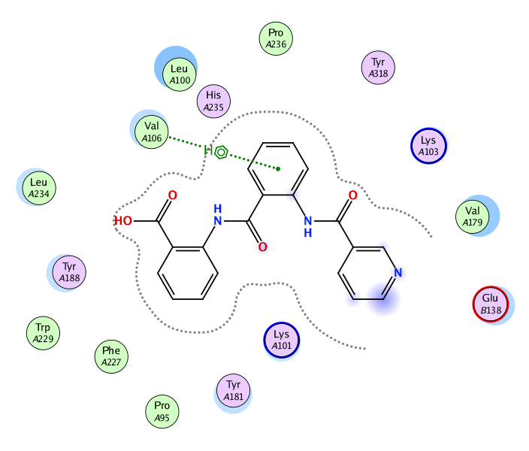 | 3.94 | H - π | Val106 | -8.47 | 2.01 | 5i
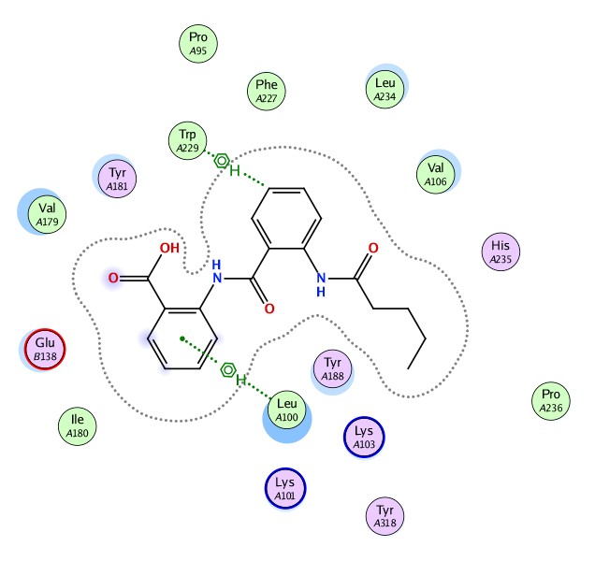 | 4.3  3.87 | H - π  H - π | Leu 100  Trp229 | -8.52 | 7.86 | 5j
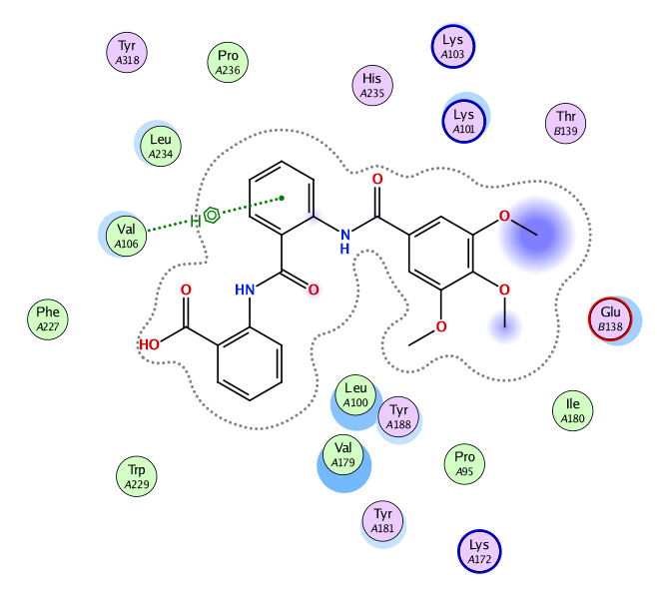 | 3.89 | H - π | Val106 | -9.35 | 0.41 | 5k

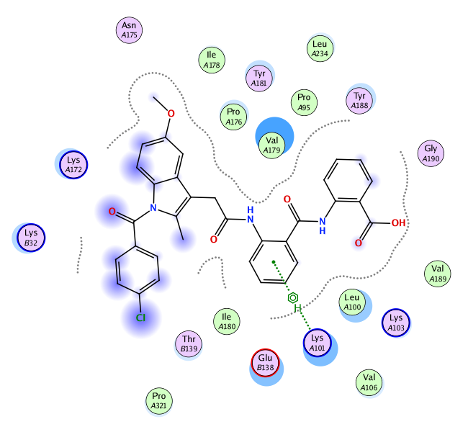 | 4.4 | H - π | Lys 101 | -8.23 | 0.24 | 5l
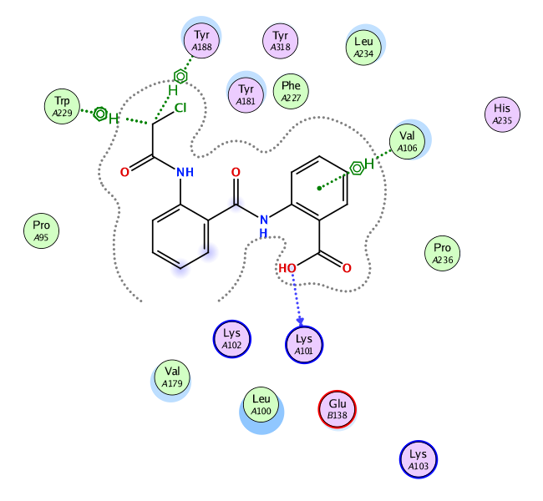 | 2.71  3.97  3.72  4.29 | H - π  H - π  H - π  H - π | Lys101  Val106  Tyr188  Trp229 | -8.23 | 3.07 | 5m
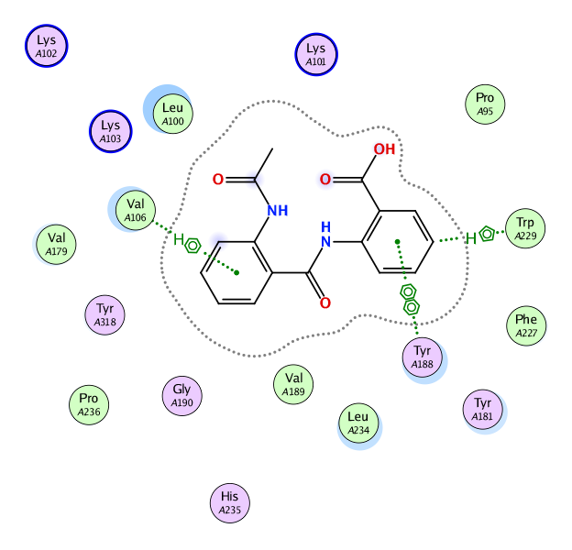 | 3.71  3.8  3.44 | H - π  π-π  H - π | Val106  Tyr188  Trp229 | -7.67 | 0.57 | 5n

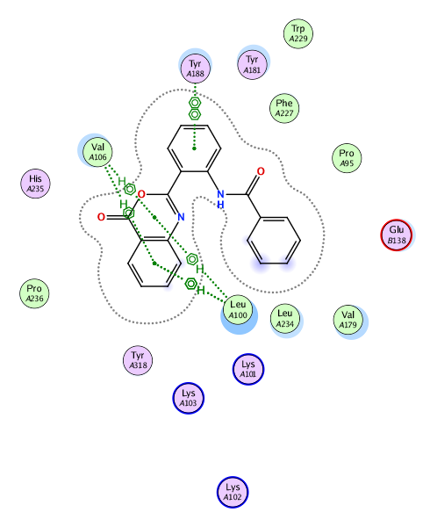 | 4.24  4.27  3.73  3.84  3.5 | H - π  H - π  H - π  H - π  π-π | Leu100  Leu100  Val106  Val106  Tyr188 | -8.43 | 2.37 | 6a
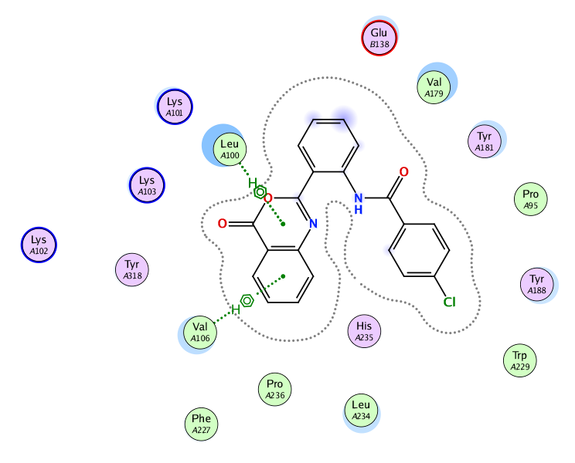 | 3.97  3.93 | H - π  H - π | Leu100  Val106 | -8.63 | 3.4 | 6b
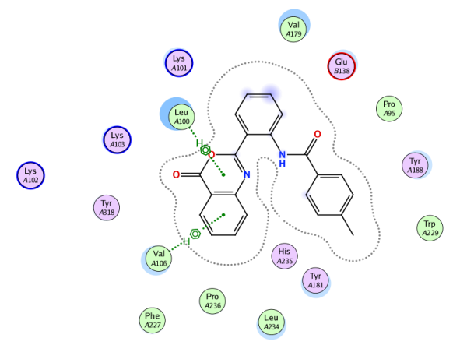 | 3.98  3.93 | H - π  H - π | Leu100  Val106 | -8.69 | 2.38 | 6c

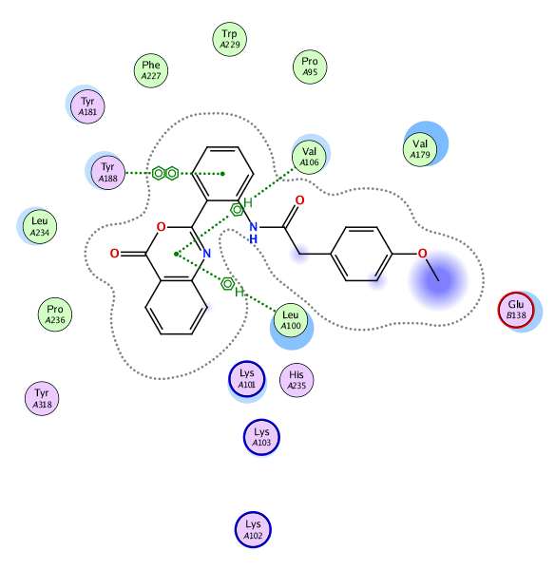 | 4.25  3.64  3.99 | H - π  H - π  π-π | Leu100  Val106  Tyr188 | -8.74 | 0.03 | 6d
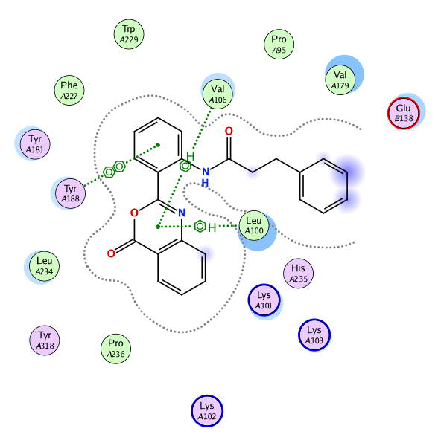 | 4.19  3.68  3.82 | H - π  H - π  π-π | Leu100  Val106  Tyr188 | -8.63 | 1.24 | 6e
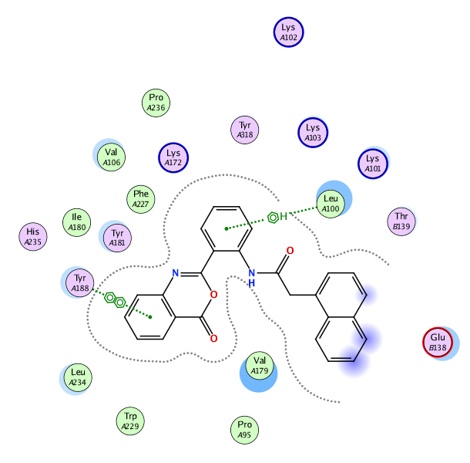 | 4.24  3.52 | H - π  π-π | Leu 100  Tyr188 | -8.33 | 0.66 | 6f
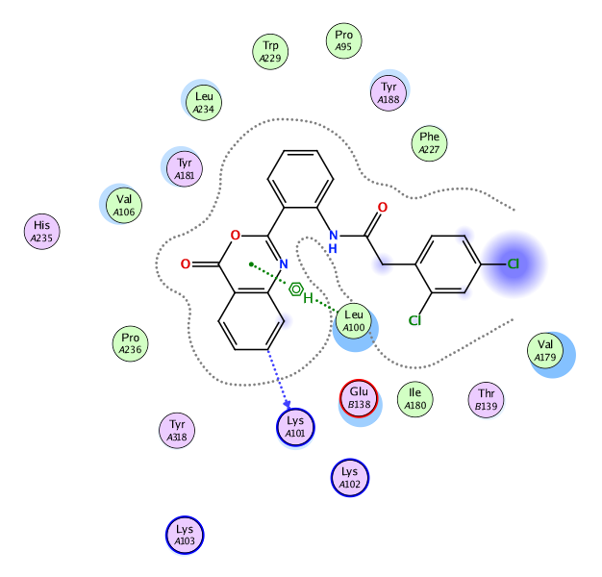 | 3.1  3.96 | H - π  H - π | Lys101  Leu100 | -8.35 | 0.72 | 6g
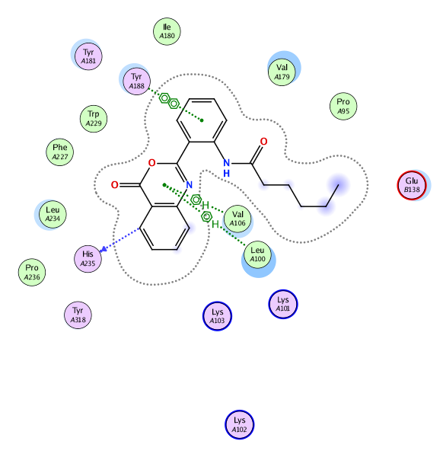 | 4.33  3.64 | H - π  H - π | Leu 100  Val106 | -8.34 | 0.36 | 6h
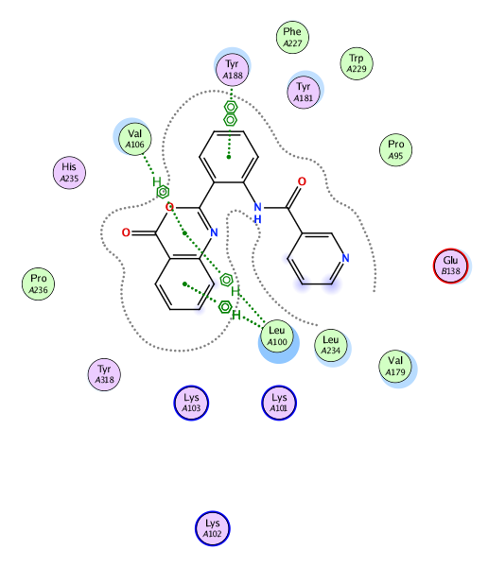 | 4.21  4.24  3.74  3.49 | H - π  H - π  H - π  π-π | Leu100  Leu100  Val106  Tyr188 | -8.54 | 1.21 | 6i
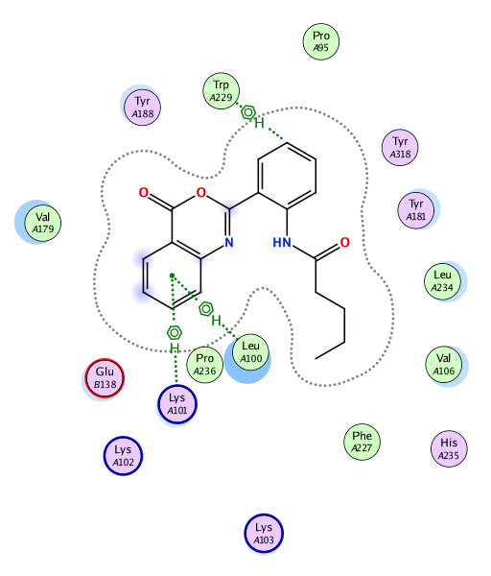 | 4.33  4.36  3.75 | H - π  H - π  H- π | Leu100  Lys101  Trp229 | -8.3 | 0.43 | 6j
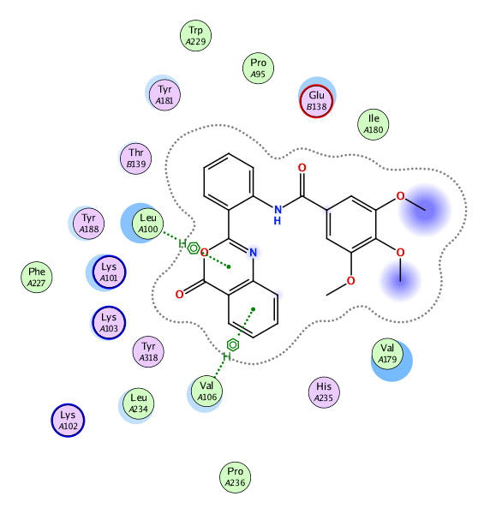 | 3.95  3.71 | H - π  H - π | Leu100  Val106 | -8.89 | 0.44 | 6k
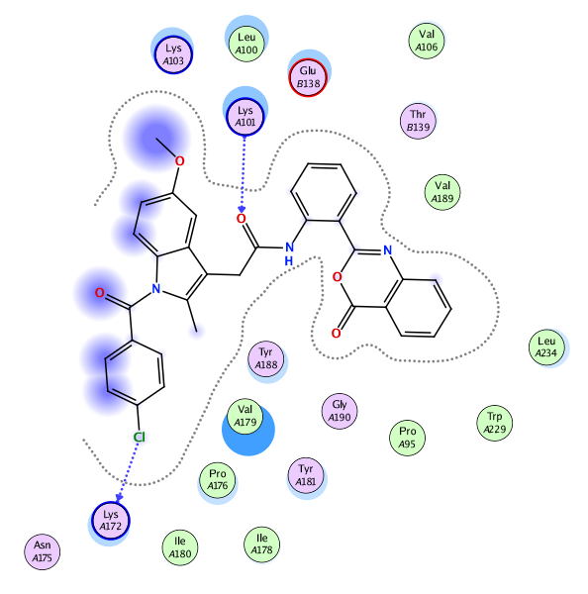 | 4.17  3.77 | H - π  H - Cl | Lys101  Lys172 | -8.19 | 0.08 | 6l

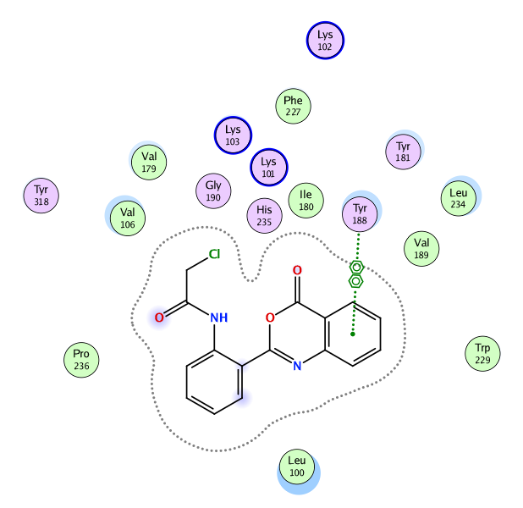 | 3.68 | π- π | Tyr188 | -7.67 | 0.42 | 6m
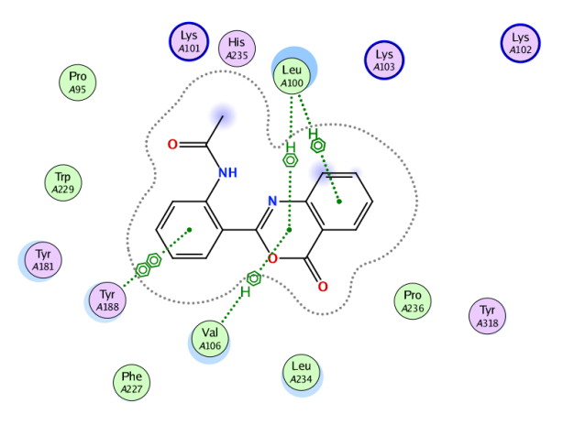 | 4.22  4.29  3.7  3.52 | H - π  H - π  H - π  π-π | Leu100  Leu100  Val106  Tyr188 | -7.67 | 3.24 | 6n

Table S2 X-ray crystallographic data of compound 6a
₂₁H₁₄N₂O₃ | Empirical formula
342.34 | Formula weight/g mol−1
0.080 × 0.050 × 0.030 | crystal size/mm
1.415 g cm−3 | calculated density
103.(2) | Temperature K
Triclinic | Lattice
'P -1', Z=2 | space group
a=8.4546(5) Å, b=9.4173(6) Å,  c=10.9991(8) Å, α=67.922(2) °,  β=83.073(2) °, γ=83.382(2) °,  V=803.27(9) Å³, Z= 2 | Unit cell dimensions
0.096 mm−1 | Absorption coefficient μ
Multi-Scan | absorption correction
0.91, 1.00 | Minimum and maximum transition factor
8324 | Measured reflections
2501 | Observed reflections
3260 | Reflections in refinement
3.209–26.362 | Theta range for data collection θ range
Full matrix least squares on F² | Refinement method
0/239 | Restraints/ Parameters
1.017 | Goodness of fit on F²(S)
R(Fobs)= 0.0459  Rw (F2)= 0.1131  mean σ(I)= 0.0501 I | Final R indices
1.415 | calc. density/g cm−3
E = 0.213 Å−3 | maximum electron density
E = −0.256Å−3 | minimum electron density
0.0480, 0.2403 | x, y (weighting scheme)
H(C) constr, H(N) refall | hydrogen refinement
0.001 | shift/errormax
0.0379 | Rint

Table S3 Docked 5a-n and 6a-nbound tothe amino acid residues in the NNIBP, and their IC₅₀usingnevirapinereference
Entry | Amino acid residues bound to the ligands |  |  |  |  |  |  |  | Ic₅₀  _{(µM)}
 | ªLeu100  (L) | ªLys101  (K) | ^{b}Val106  (V) | Lys172  (K) | ^{b}Tyr188  (Y) | Trp229  (W) | Leu234  (L) | His235 (H)
Nevirapine | - | - | + | - | + | - | + | - | 0.11
5a | + | - | + | - | - | - | - | - | 0.37
5b | + | - | - | - | - | + | - | - | 1.37
5c | - | + | + | - | - | - | - | - | 0.37
5d | - | - | - |  | - | - | + | - | 1.35
5e | + | + | + | - | - | - | - | - | 123.5
5f | + | - | - | - | - | + | - | - | 17.73
5g | - | - | + | - | - | - | - | - | 4.76
5h | + | + | - | - | - | - | - | - | 5.10
5i | - | - | + | - | - | - | - | - | 2.01
5j | + | - | - | - | - | + | - | - | 7.86
5k | - | - | + | - | - | - | - | - | 0.41
5l | - | + | - | - | - | - | - | - | 0.24
5m | - | + | + | - | + | + | - | - | 3.07
5n | - | - | + | - | + | + | - | - | 0.57
6a | ++ | - | ++ | - | + | - | - | - | 2.37
6b | + | - | + | - | - | - | - | - | 3.4
6c | + | - | + | - | - | - | - | - | 2.38
6d | + | - | + | - | + | - | - | - | 0.03
6e | + | - | + | - | + | - | - | - | 1.24
6f | + | - | - | - | + | - | - | - | 0.66
6g | + | + | - | - | - | - | - | - | 0.72
6h | + | - | + | - | + | - | - | + | 0.36
6i | ++ | - | + | - | + | - | - | - | 1.21
6j | + | + | - | - | - | + | - | - | 0.43
6k | + | - | + | - | - | - | - | - | 0.44
6l | - | + | - | + | - | - | - | - | 0.08
6m | - | - | - | - | + | - | - | - | 0.42
6n | ++ | - | + | - | + | - | - | - | 3.25

ª minor mutable residue, ^{b} major mutable residues, + = one interaction, ++ = two interactions,$-$= no interaction.

Table S4 Calculated energy descriptors of 5 a-n and 6 a-n
Compd. | IC₅₀  (µM) | HOMO  (eV) | LUMO  (eV) | ∆ E= (HOMO -LUMO) (eV) | I=  - E_{HOMO} | A=  -E_{LUMO} | χ=  (I+A)/2 | η=  (I-A)/2 | S=  1/2η | µ=  - (I+A)/2 | ω  = µ²/2η
5a | 0.37 | -9.030 | -0.516 | -8.514 | 9.030 | 0.516 | 4.773 | 4.257 | 0.117 | -4.773 | 2.676
5b | 1.37 | -9.177 | -0.608 | -8.569 | 9.177 | 0.608 | 4.892 | 4.285 | 0.117 | -4.892 | 2.793
5c | 0.37 | -8.815 | -0.536 | -8.279 | 8.815 | 0.536 | 4.676 | 4.139 | 0.121 | -4.676 | 2.641
5d | 1.35 | -8.841 | -0.512 | -8.329 | 8.841 | 0.512 | 4.676 | 4.165 | 0.120 | -4.676 | 2.626
5e | 123.5 | -8.880 | -0.565 | -8.315 | 8.880 | 0.565 | 4.723 | 4.157 | 0.120 | -4.723 | 2.682
5f | 17.7 | -8.650 | -0.508 | -8.143 | 8.650 | 0.508 | 4.579 | 4.071 | 0.123 | -4.579 | 2.575
5g | 4.76 | -8.981 | -0.541 | -8.440 | 8.981 | 0.541 | 4.761 | 4.220 | 0.118 | -4.761 | 2.686
5h | 5.1 | -8.837 | -0.547 | -8.291 | 8.837 | 0.547 | 4.692 | 4.145 | 0.121 | -4.692 | 2.656
5i | 2.01 | -9.075 | -0.572 | -8.503 | 9.075 | 0.572 | 4.824 | 4.251 | 0.118 | -4.824 | 2.737
5j | 7.86 | -8.835 | -0.557 | -8.278 | 8.835 | 0.557 | 4.696 | 4.139 | 0.121 | -4.696 | 2.664
5k | 0.41 | -8.933 | -0.607 | -8.326 | 8.933 | 0.607 | 4.770 | 4.163 | 0.120 | -4.770 | 2.732
5l | 0.24 | -8.512 | -0.478 | -8.033 | 8.512 | 0.478 | 4.495 | 4.017 | 0.124 | -4.495 | 2.515
5m | 3.07 | -9.042 | -0.572 | -8.470 | 9.042 | 0.572 | 4.807 | 4.235 | 0.118 | -4.807 | 2.728
5n | 0.57 | -8.874 | -0.539 | -8.335 | 8.874 | 0.539 | 4.707 | 4.167 | 0.120 | -4.707 | 2.658
6a | 2.37 | -8.983 | -1.107 | -7.877 | 8.983 | 1.107 | 5.045 | 3.938 | 0.127 | -5.045 | 3.231
6b | 3.4 | -9.058 | -1.150 | -7.908 | 9.058 | 1.150 | 5.104 | 3.954 | 0.126 | -5.104 | 3.294
6c | 2.38 | -8.950 | -1.093 | -7.857 | 8.950 | 1.093 | 5.021 | 3.928 | 0.127 | -5.021 | 3.209
6d | 0.03 | -8.920 | -1.081 | -7.839 | 8.920 | 1.081 | 5.000 | 3.920 | 0.128 | -5.000 | 3.190
6e | 1.24 | -8.968 | -1.156 | -7.812 | 8.968 | 1.156 | 5.062 | 3.906 | 0.128 | -5.062 | 3.280
6f | 0.66 | -8.807 | -1.087 | -7.720 | 8.807 | 1.087 | 4.947 | 3.860 | 0.130 | -4.947 | 3.170
6g | 0.72 | -9.093 | -1.111 | -7.982 | 9.093 | 1.111 | 5.102 | 3.991 | 0.125 | -5.102 | 3.261
6h | 0.36 | -8.973 | -1.121 | -7.852 | 8.973 | 1.121 | 5.047 | 3.926 | 0.127 | -5.047 | 3.244
6i | 1.21 | -9.086 | -1.187 | -7.899 | 9.086 | 1.187 | 5.137 | 3.950 | 0.127 | -5.137 | 3.340
6j | 0.43 | -8.972 | -1.122 | -7.851 | 8.972 | 1.122 | 5.047 | 3.925 | 0.127 | -5.047 | 3.245
6k | 0.44 | -8.980 | -1.165 | -7.815 | 8.980 | 1.165 | 5.073 | 3.907 | 0.128 | -5.073 | 3.292
6l | 0.08 | -8.679 | -1.153 | -7.526 | 8.679 | 1.153 | 4.916 | 3.763 | 0.133 | -4.916 | 3.212
6m | 0.42 | -9.148 | -1.172 | -7.977 | 9.148 | 1.172 | 5.160 | 3.988 | 0.125 | -5.160 | 3.338
6n | 3.25 | -8.988 | -1.134 | -7.855 | 8.988 | 1.134 | 5.061 | 3.927 | 0.127 | -5.061 | 3.261

Figure S1 ¹H NMR spectrum of 5a
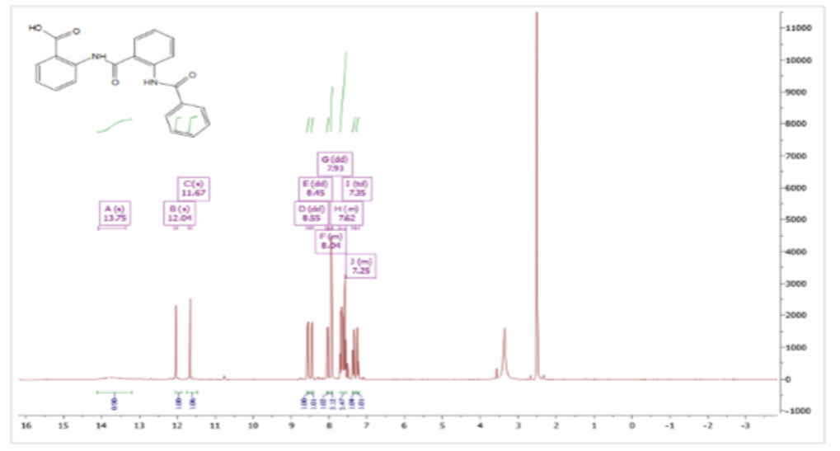
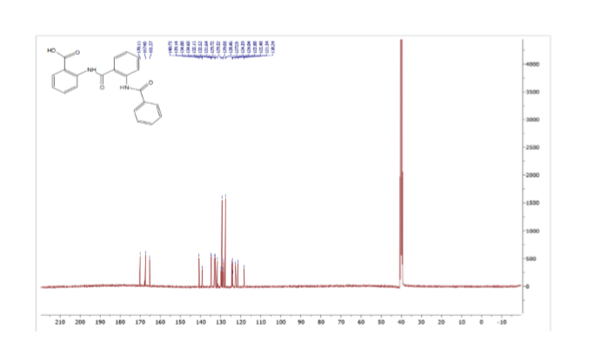
Figure S2 ¹³CNMR spectrum of 5a

Figure S3 FT-IR spectrum 5a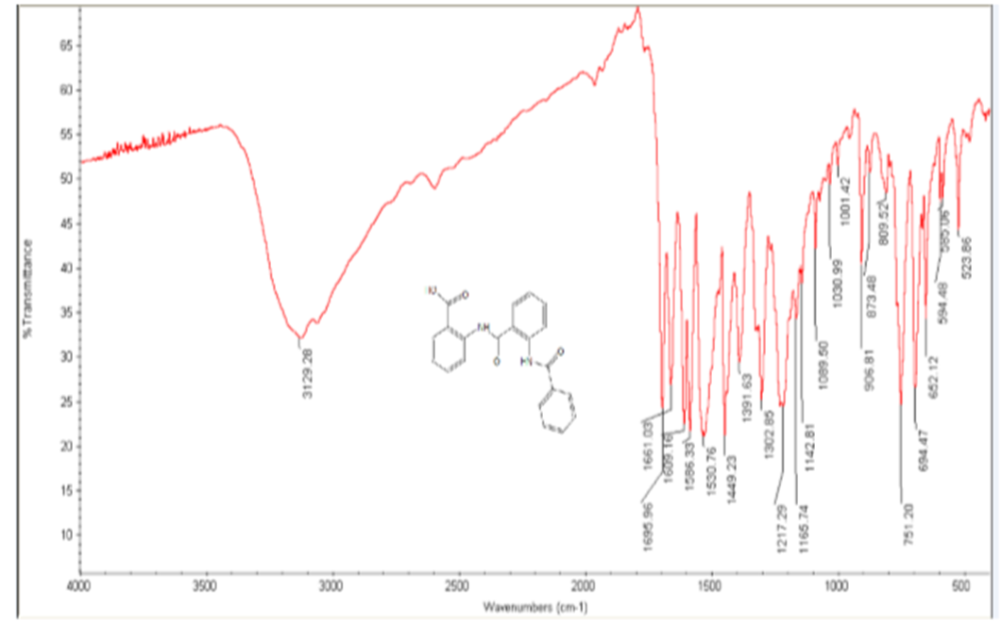

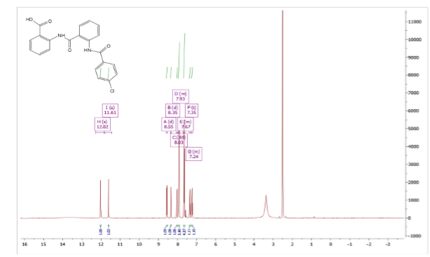
Figure S4 ¹H NMR spectrum of 5b

Figure S5 ¹³CNMR spectrum of 5b
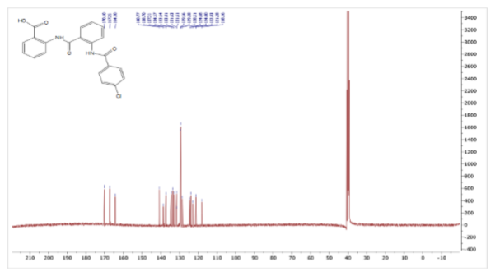
Figure S6 FT-IR spectrum of 5b
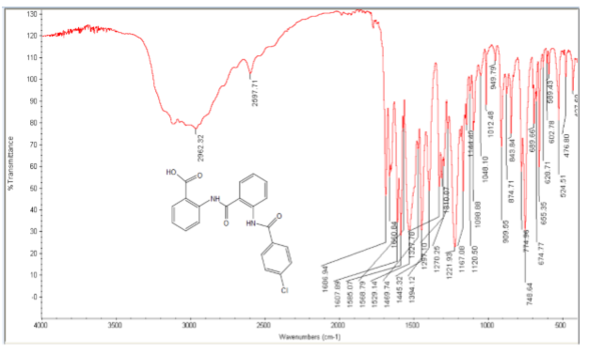
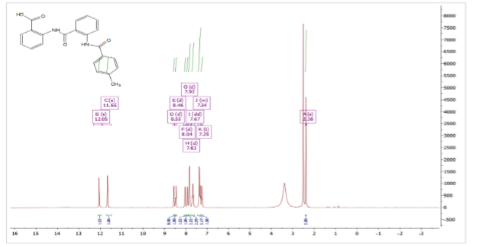
Figure S7 ¹H NMR spectrum of 5c

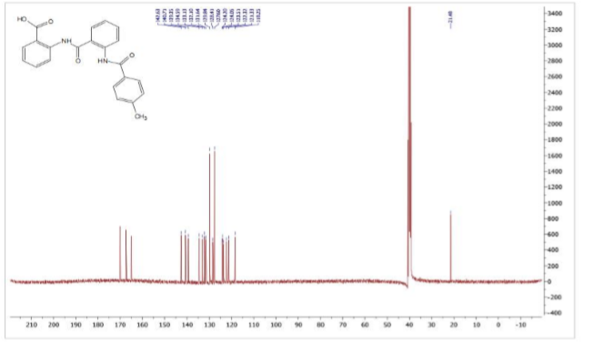
Figure S8 ¹³NMR spectrum of 5c

Figure S9 Ft-IR spectrum 5c
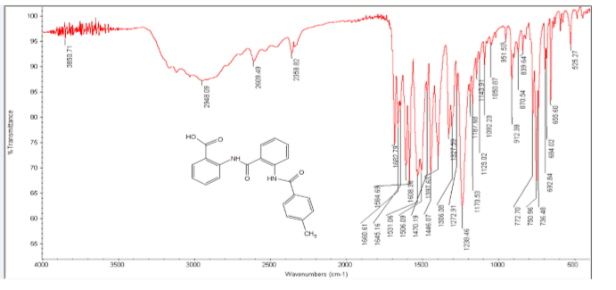
Figure S10¹H NMR spectrum of 5d
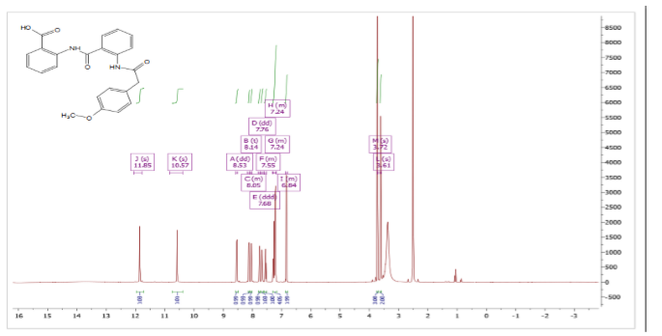

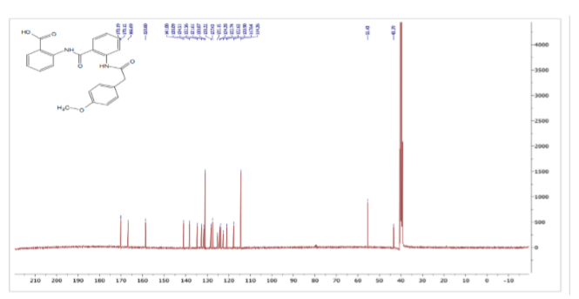
Figure S11 ¹³CNMR spectrum of 5d

Figure S12 FT-IR spectrum of 5d
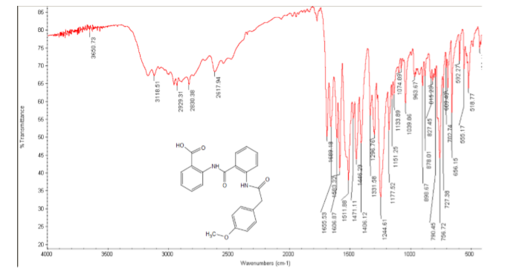

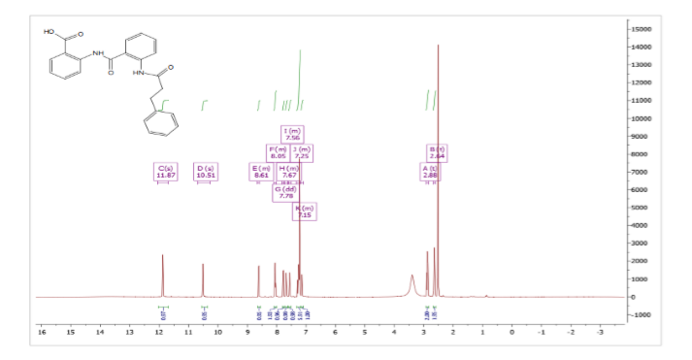
Figure S13 ¹H NMR spectrum of 5e
Figure S14 ¹³CNMR spectrum of 5e
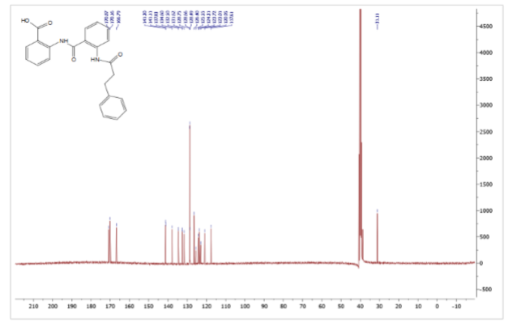

Figure S15 FT-IR spectrum of 5e
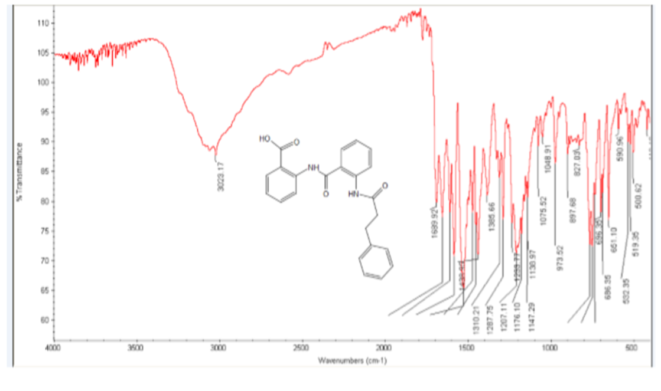
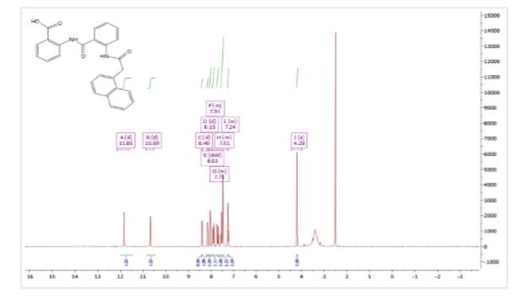
Figure S16 ¹H NMR spectrum of 5f

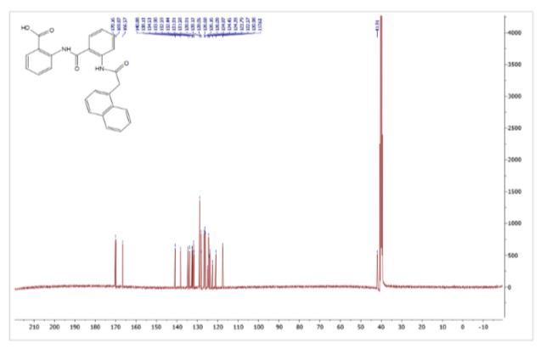
Figure S17¹³CNMR spectrum of 5f

Figure S18 FT-IR spectrum of 5f
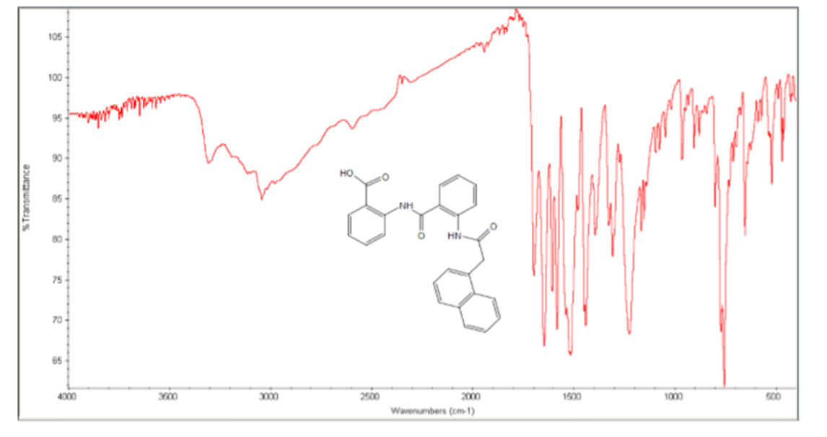

Figure S19 ¹H NMR spectrum of5g
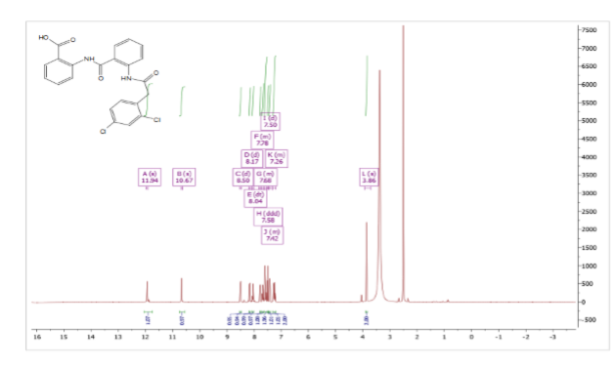

Figure S20 ¹³CNMR spectrum of5g
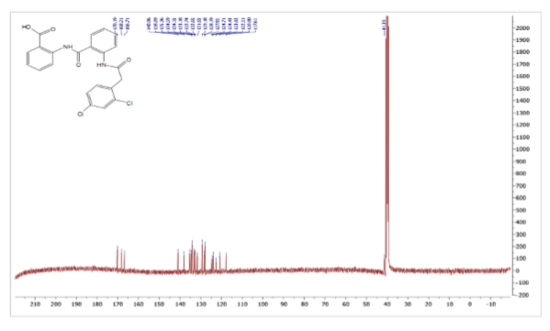

Figure S21 FT-IR spectrum of5g
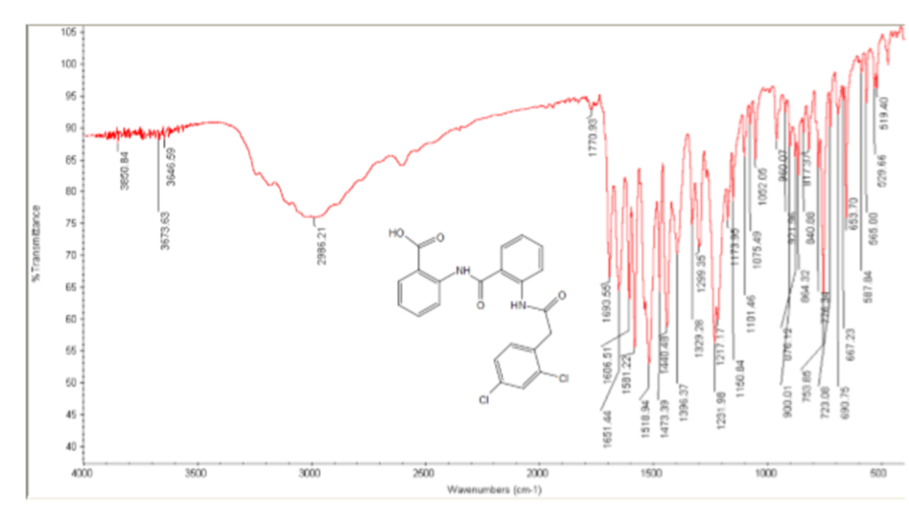
Figure S22 ¹H NMR spectrum of5h
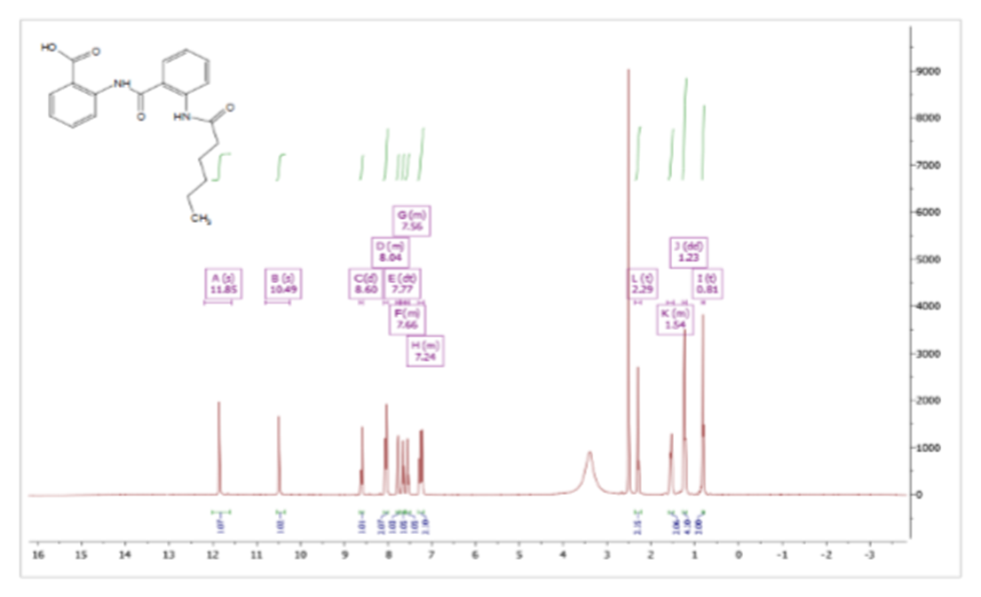

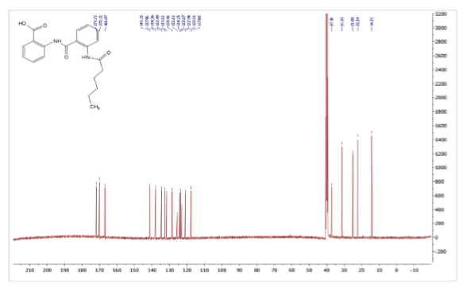
Figure S23 ¹³CNMR spectrum of5h
Figure S24 FT-IR spectrum of5h
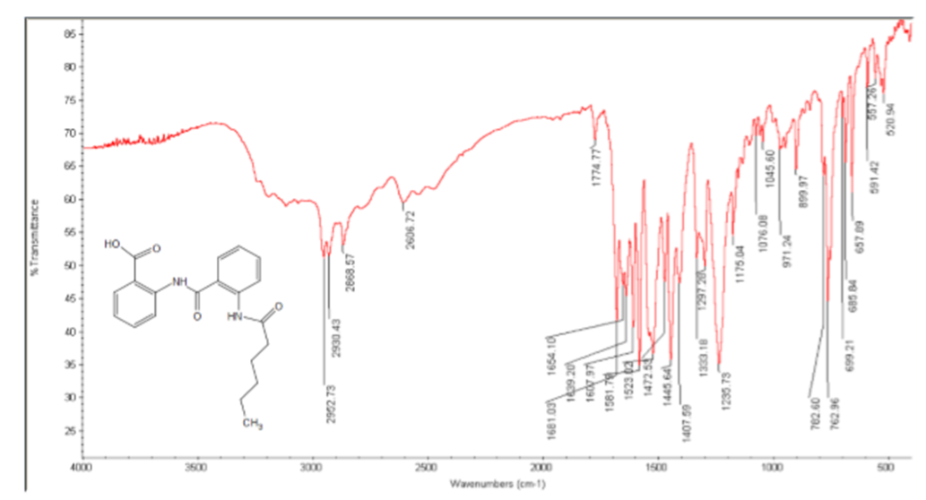

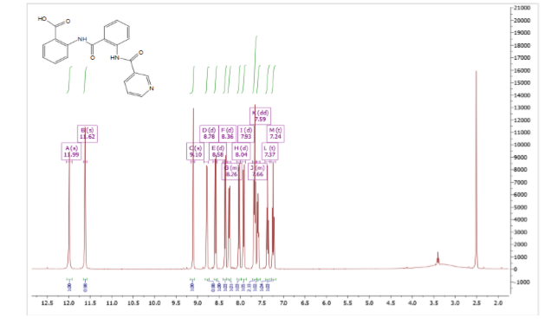
Figure S25 ¹H NMR spectrum of5i

Figure S26 ¹³CNMR spectrum of5i
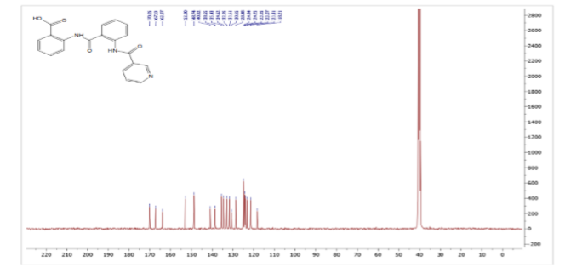

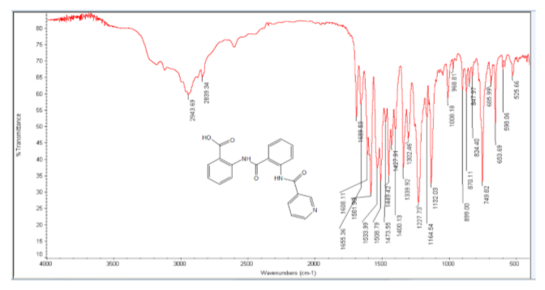
Figure S27 FT-IR spectrum of5i

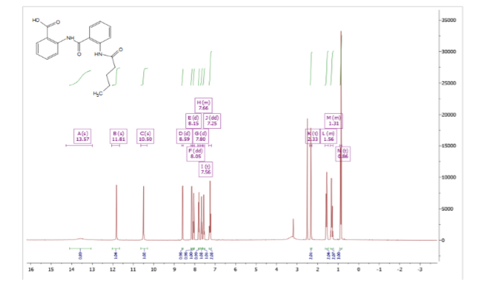
Figure S28 ¹H NMR spectrum of5j

Figure S29 ¹³CNMR spectrum of5j
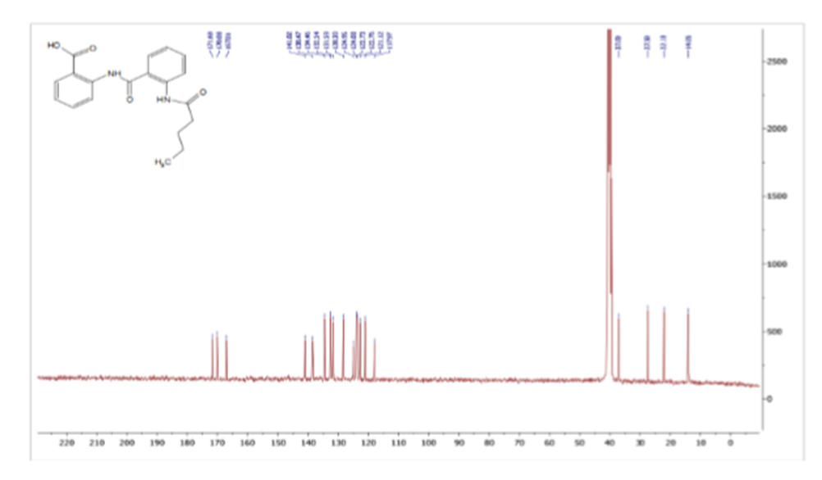
Figure S30 FT-IR spectrum of5j
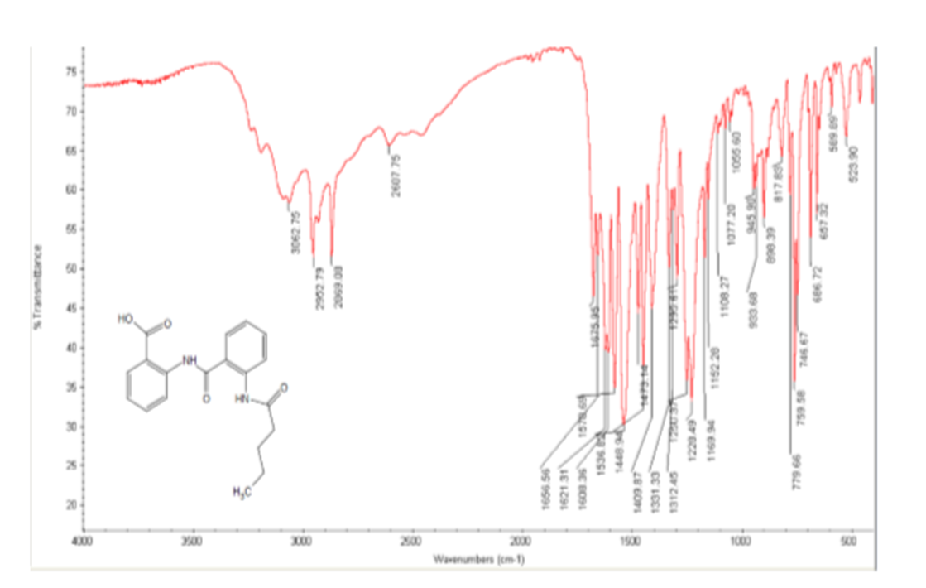

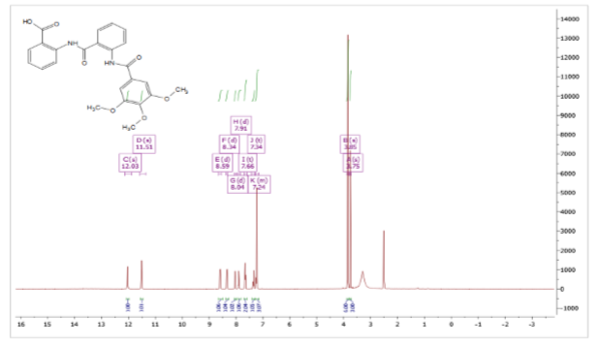
Figure S31 ¹H NMR spectrum of 5k
Figure S32 ¹³CNMR spectrum of5k
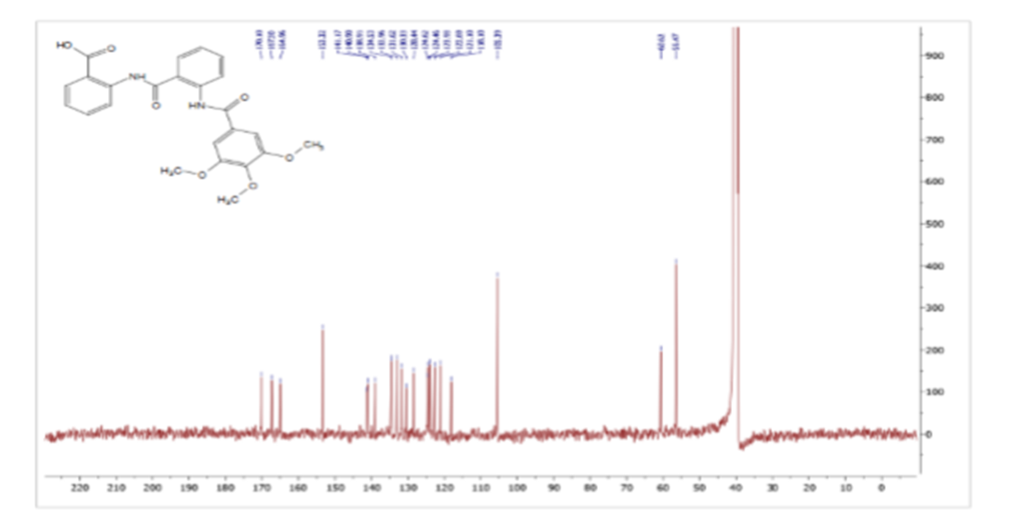

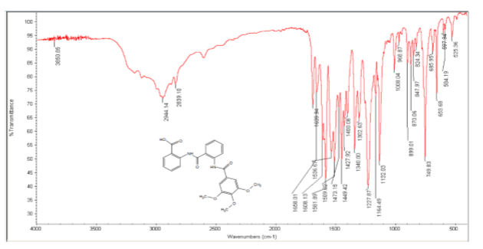
Figure S33 FT-IR spectrum of 5k

Figure S34¹H NMR spectrum of 5l
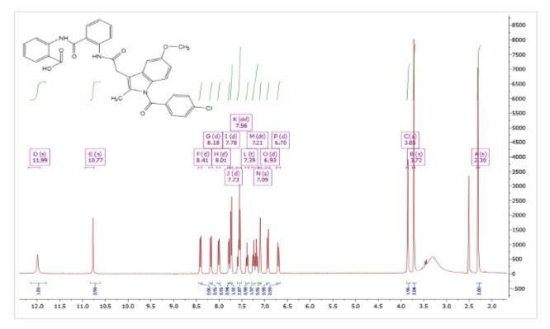

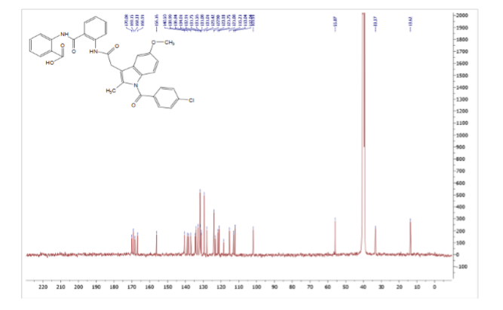
Figure S35¹³CNMR spectrum of 5l

Figure S36FT-IR spectrum of 5l
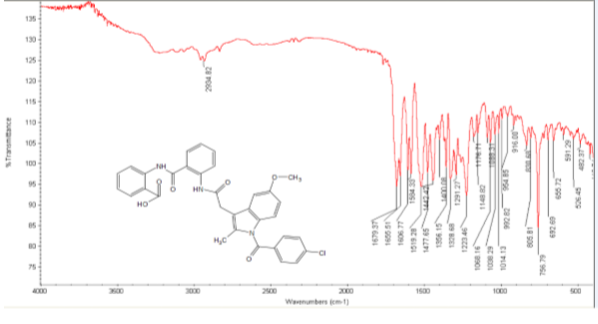

Figure S37¹H NMR spectrum of 5m
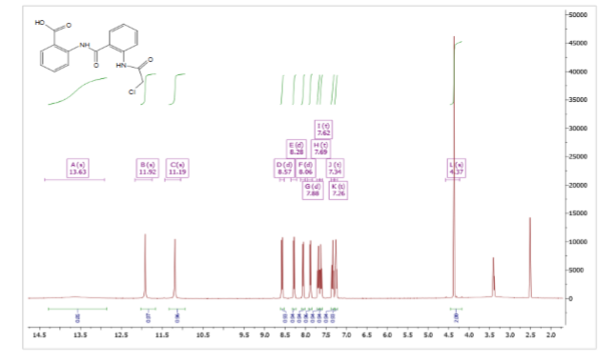

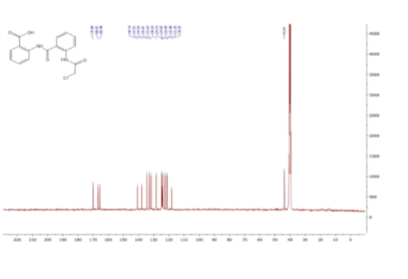
Figure S38¹³CNMR spectrum of 5m

Figure S39FT-IR spectrum of 5m

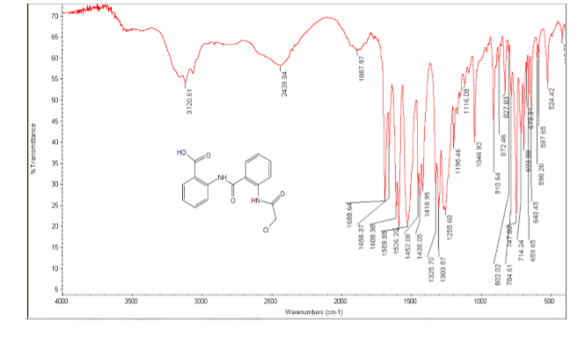

Figure S40¹H NMR spectrum of 5n
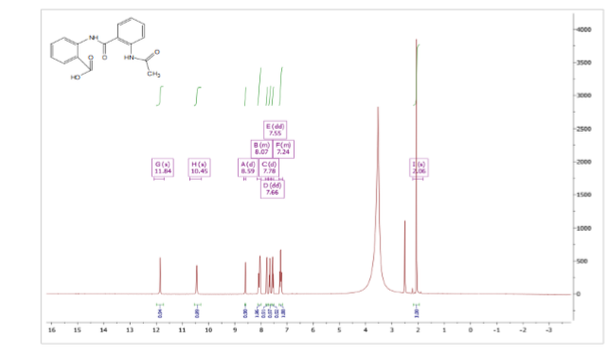
Figure S41 ¹³CNMR spectrum of 5n
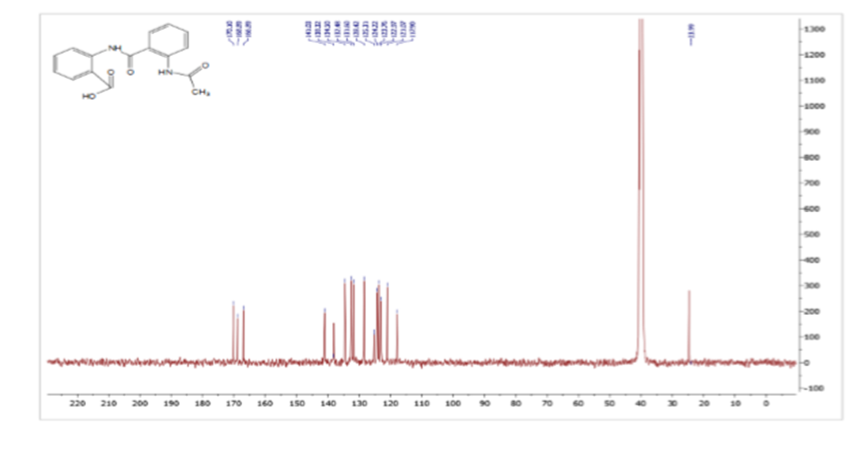
Figure S42¹H NMR spectrum of 6a
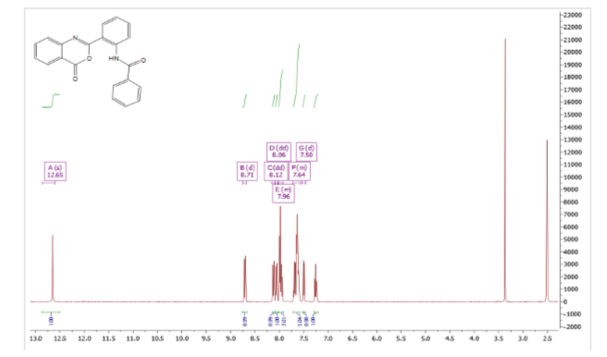

Figure S43¹³CNMR spectrum of 6a
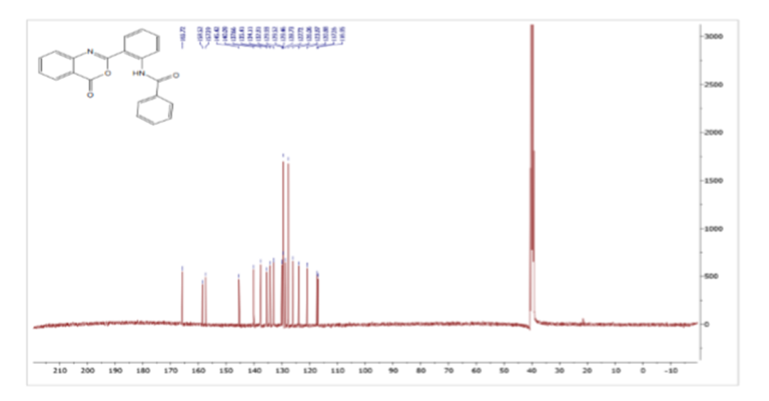
Figure S44FT-IR spectrum of 6a

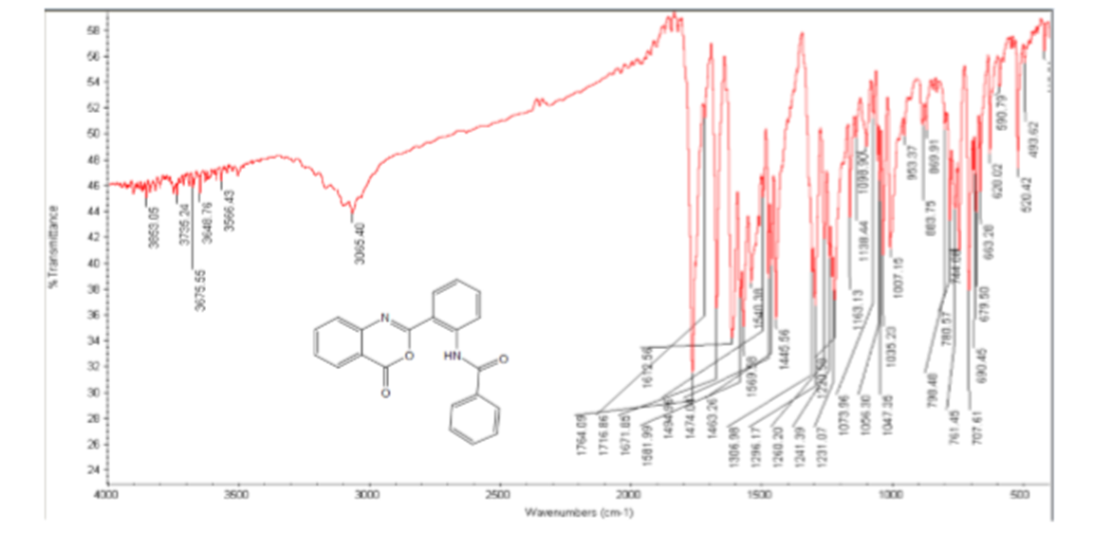

Figure S45¹H NMR spectrum of 6b
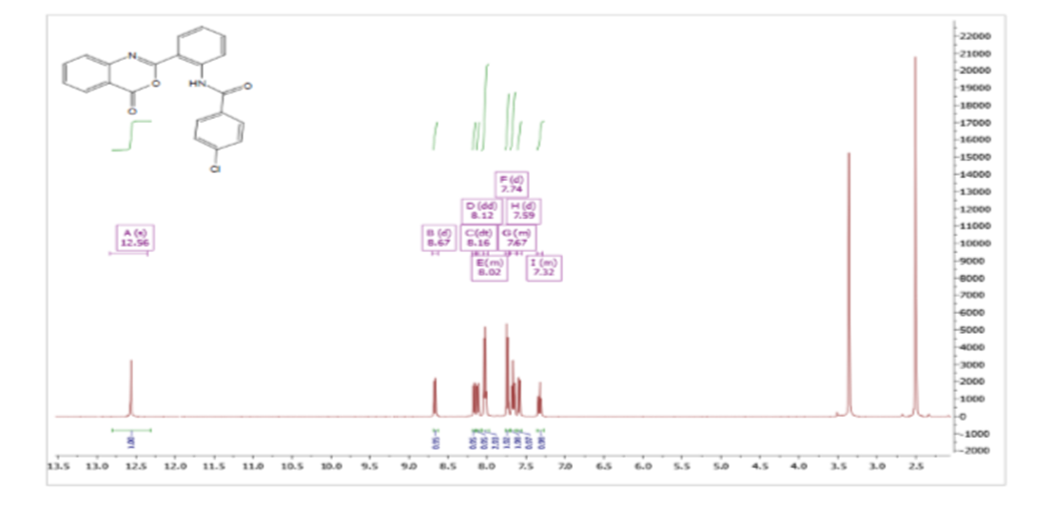
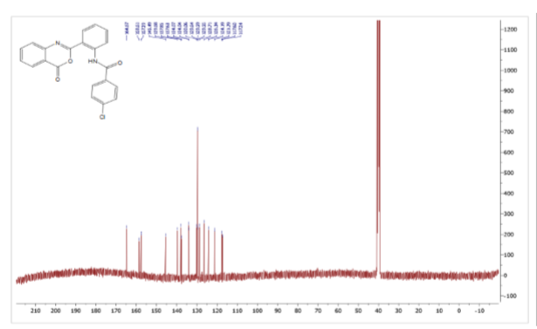
Figure S46 ¹³CNMR spectrum of 6b

Figure S47 FT-IR spectrum of 6b
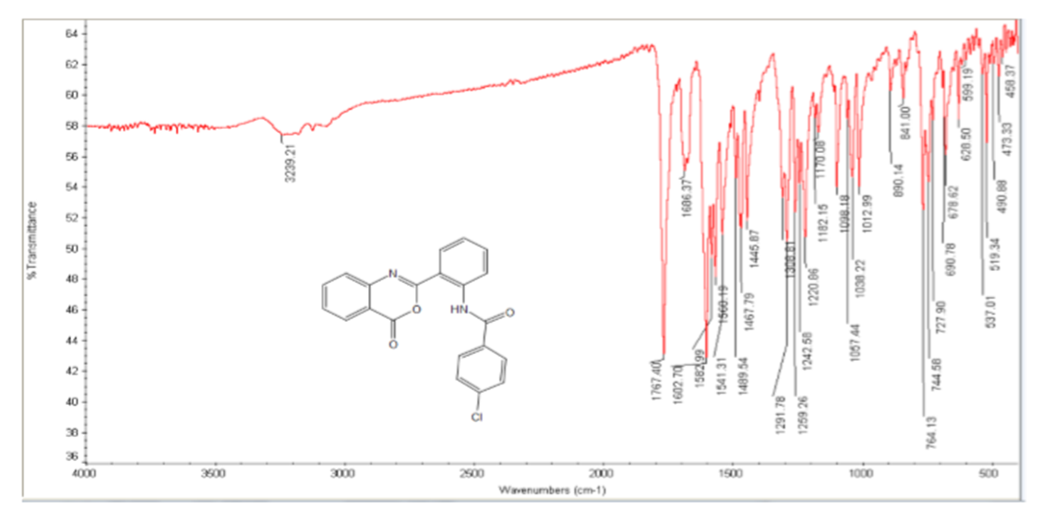
Figure S48 ¹H NMR spectrum of 6c
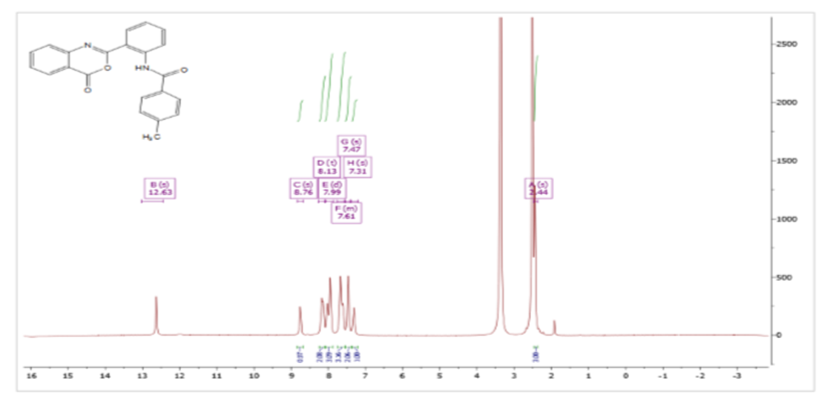
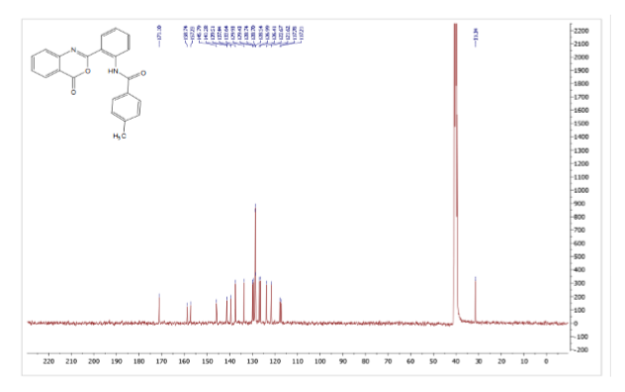
Figure S49 ¹³CNMR spectrum of 6c

Figure S50 FT-IR spectrum of 6c
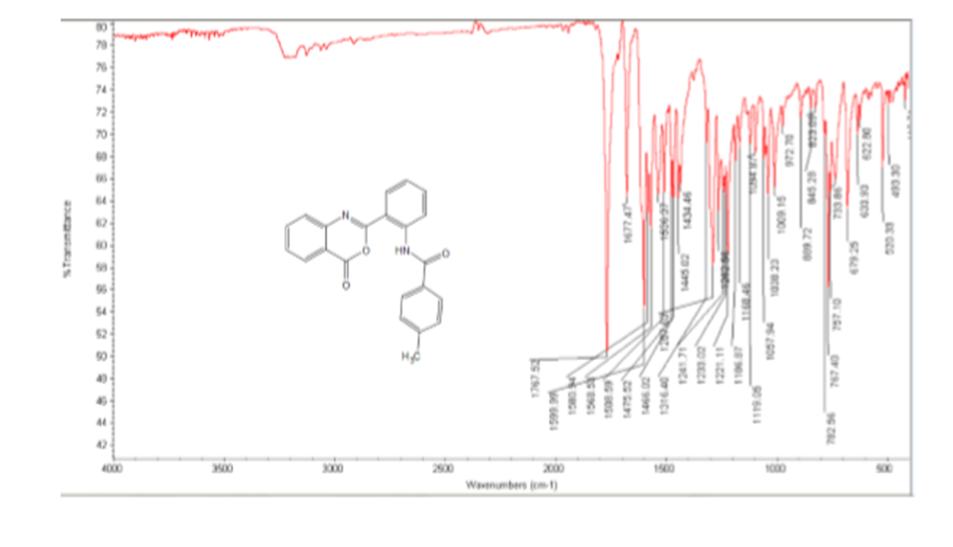

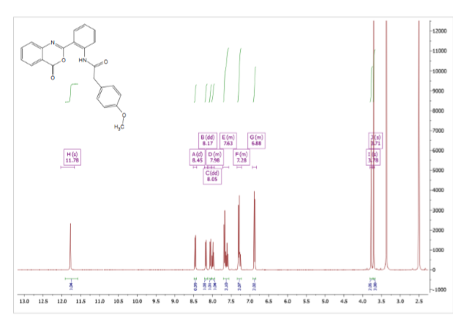
Figure S51 ¹H NMR spectrum of 6d

Figure S52 ¹³CNMR spectrum of 6d
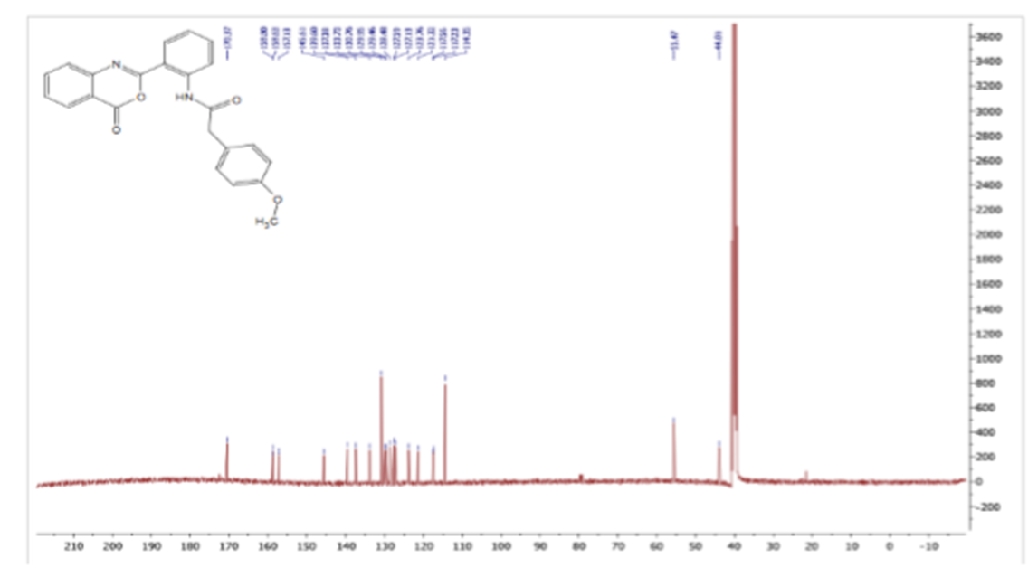

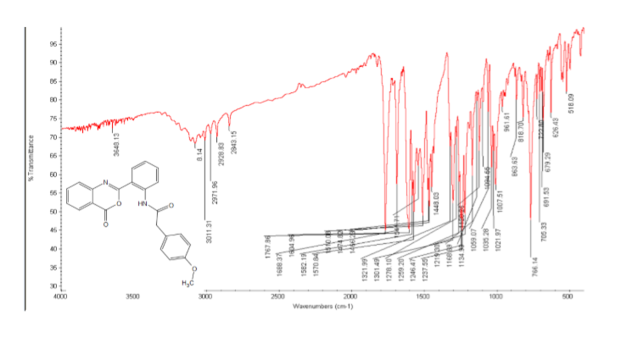
Figure S53 FT-IR spectrum of 6d
Figure S54 ¹H NMR spectrum of 6e
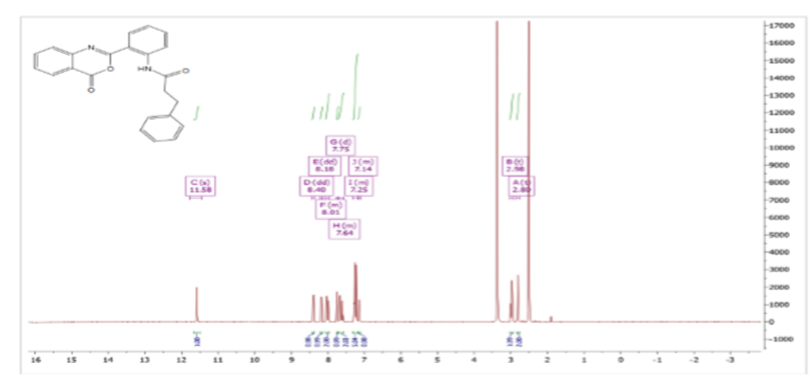

Figure S55 ¹³CNMR spectrum of 6e
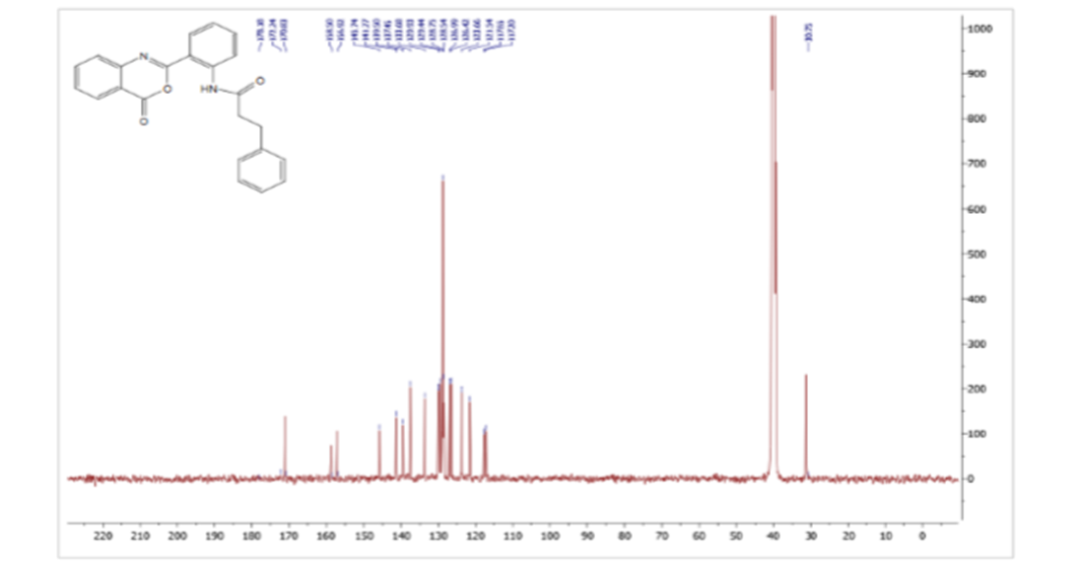

Figure S56 FT-IR spectrum of 6e
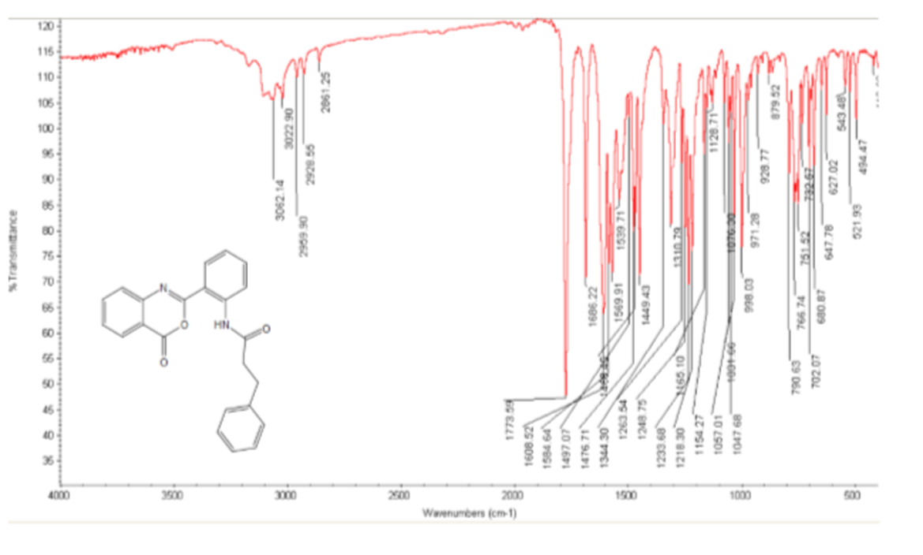
Figure S57 ¹H NMR spectrum of 6f
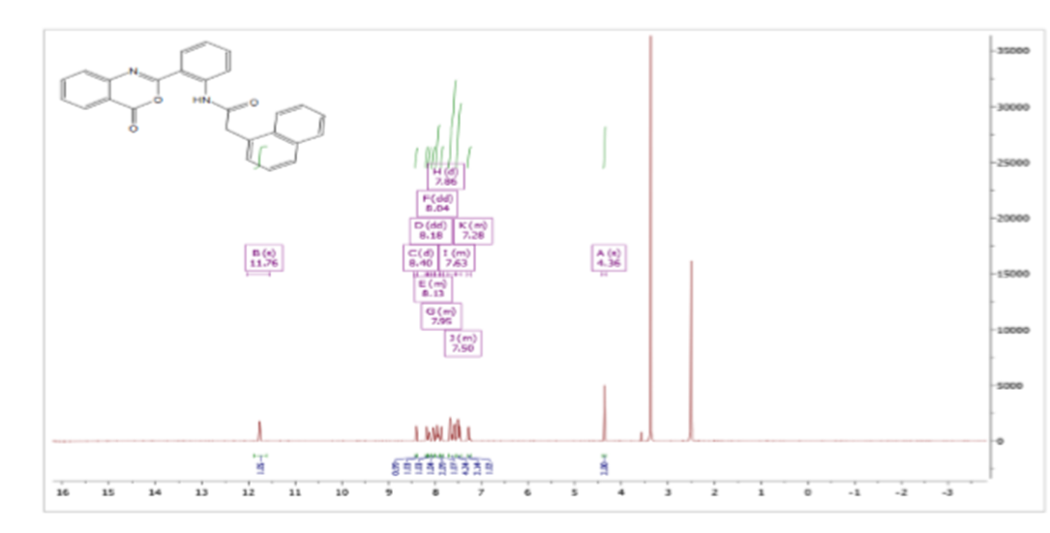
Figure S58 ¹³CNMR spectrum of 6f
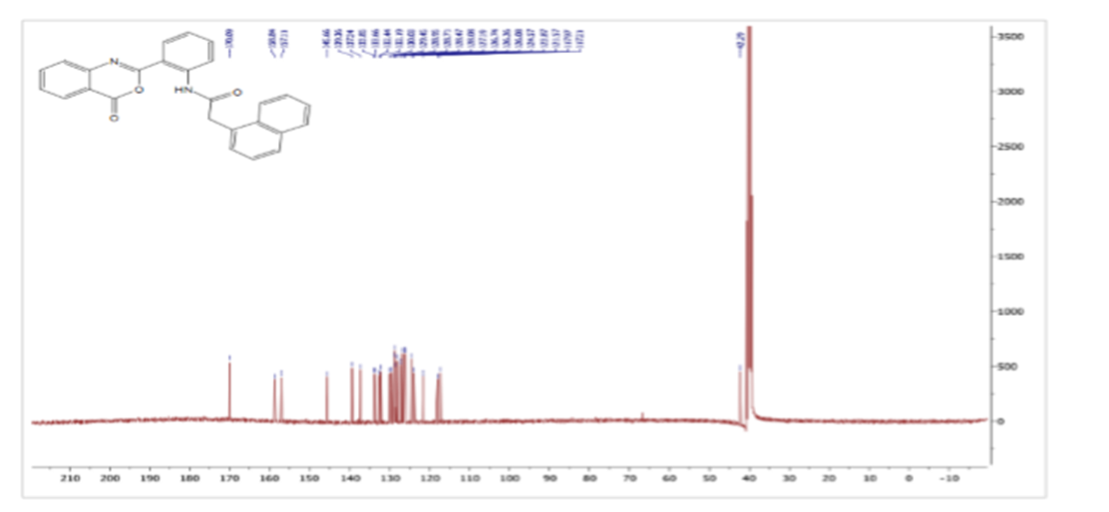

Figure S59 FT-IR spectrum of 6f

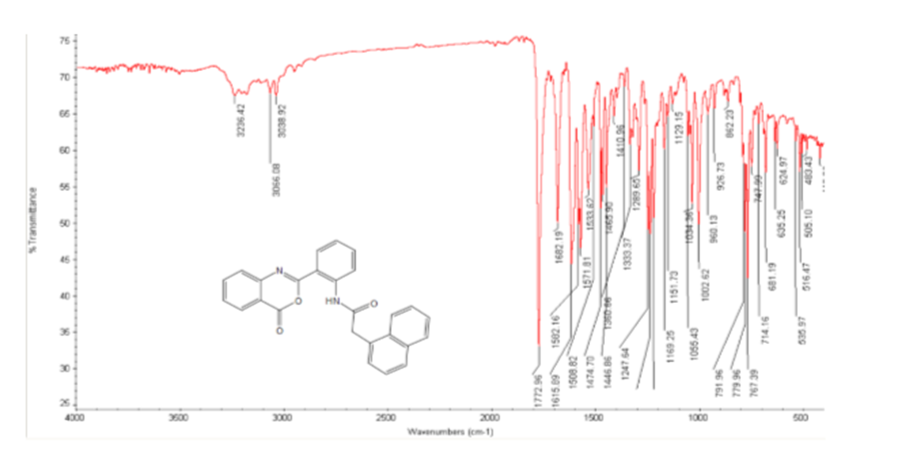
Figure S60 ¹H NMR spectrum of 6g
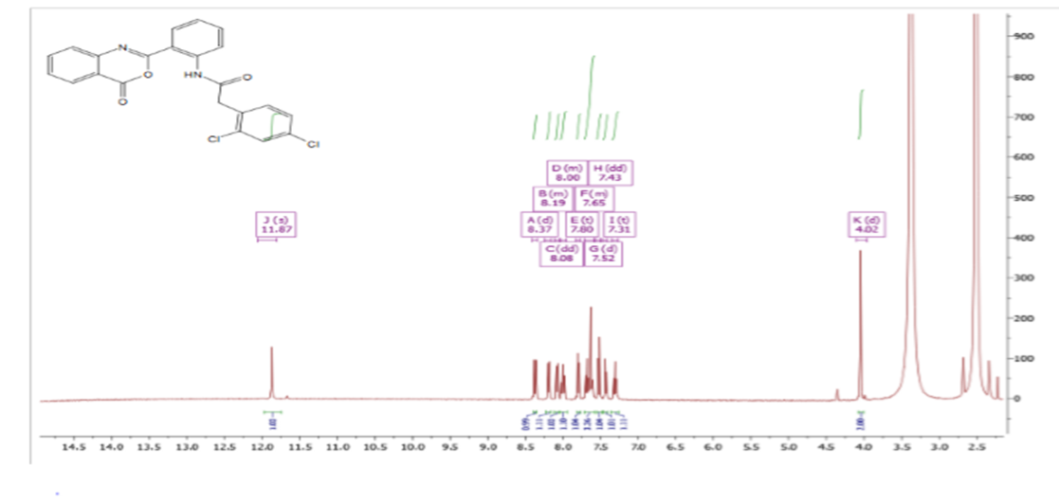

Figure S61 ¹³CNMR spectrum of 6g
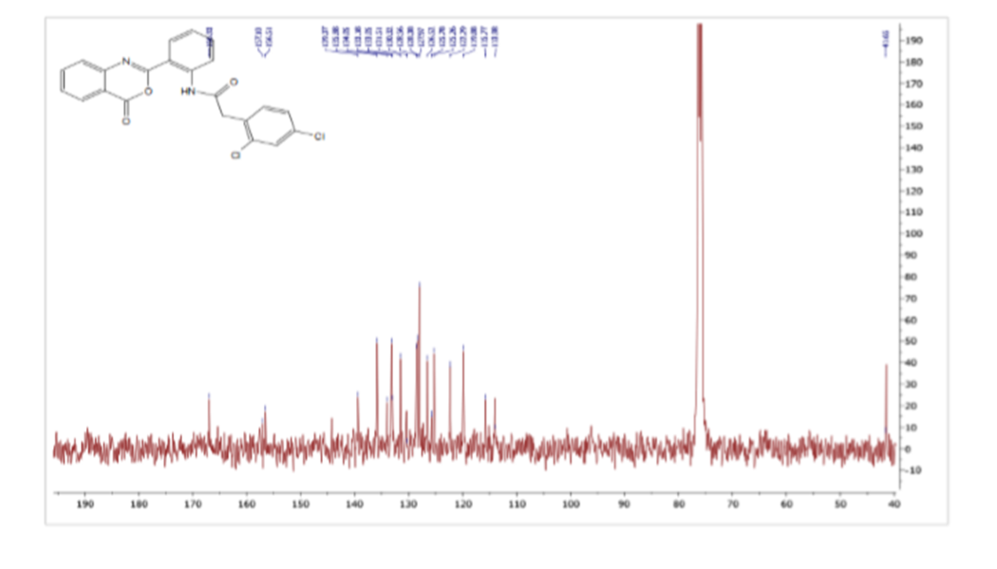

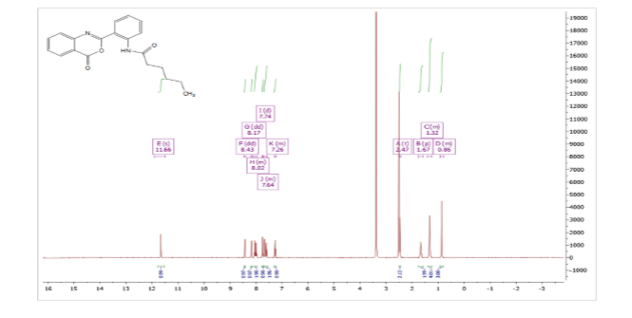
Figure S62 ¹H NMR spectrum of 6h

Figure S63 ¹³CNMR spectrum of 6h
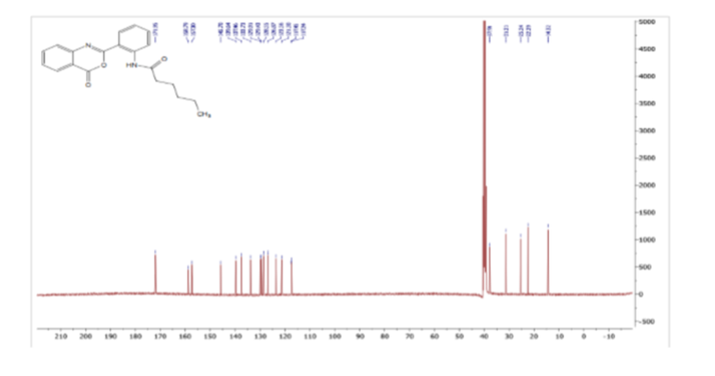
Figure S64 FT-IR spectrum of 6h
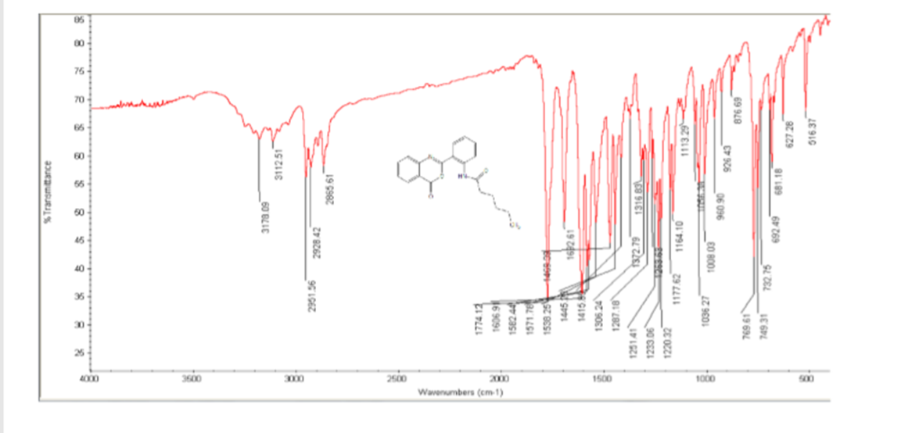

Figure S65¹H NMR spectrum of 6i
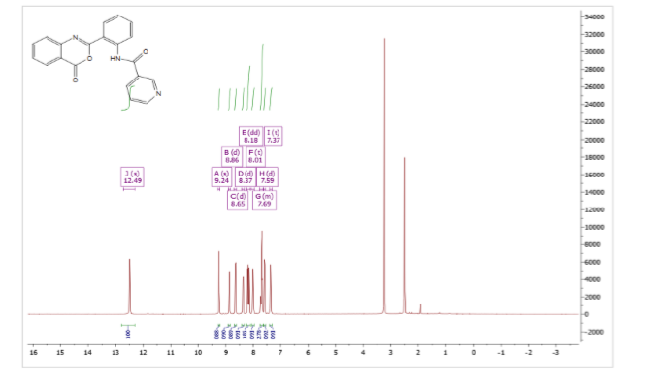

Figure S66¹³CNMR spectrum of 6i
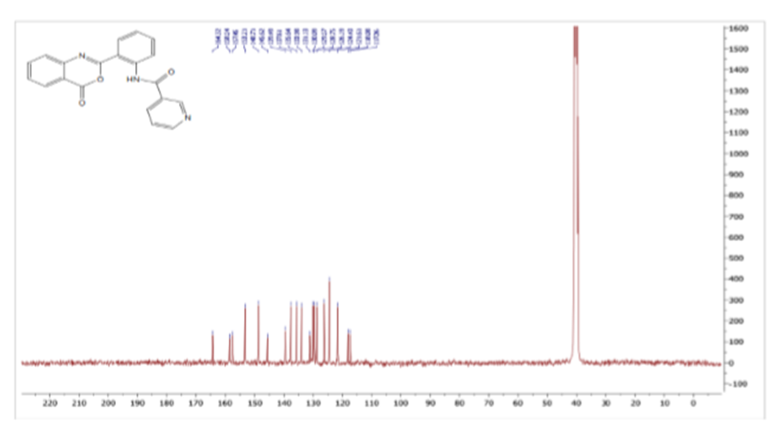
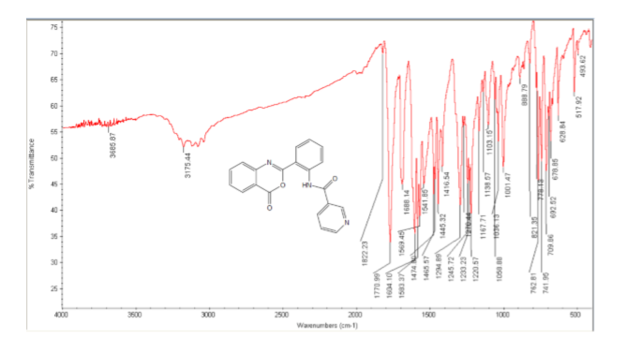
Figure S67 FT-IR spectrum of 6i

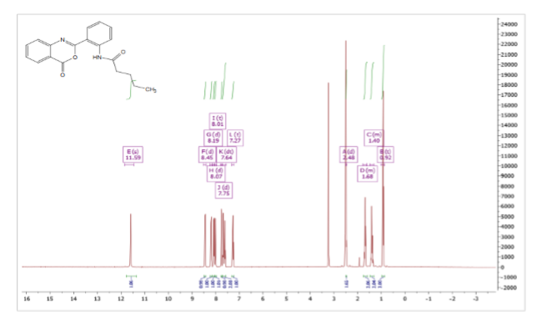
Figure S68¹H NMR spectrum of 6j

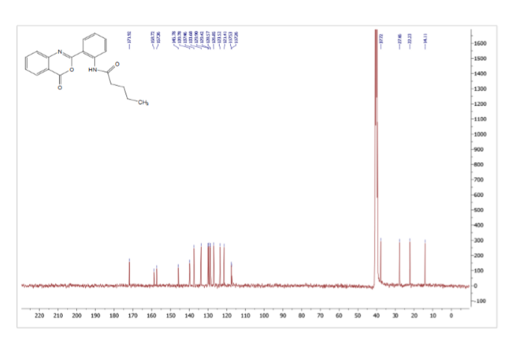
Figure S69¹³CNMR spectrum of 6j

Figure S70FT-IR spectrum of 6j
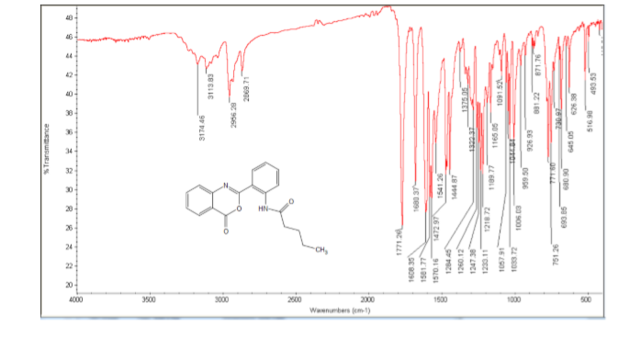

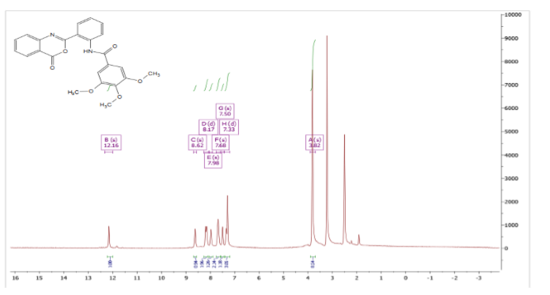
Figure S71 ¹H NMR spectrum of 6k

Figure S72 ¹³CNMR spectrum of 6k
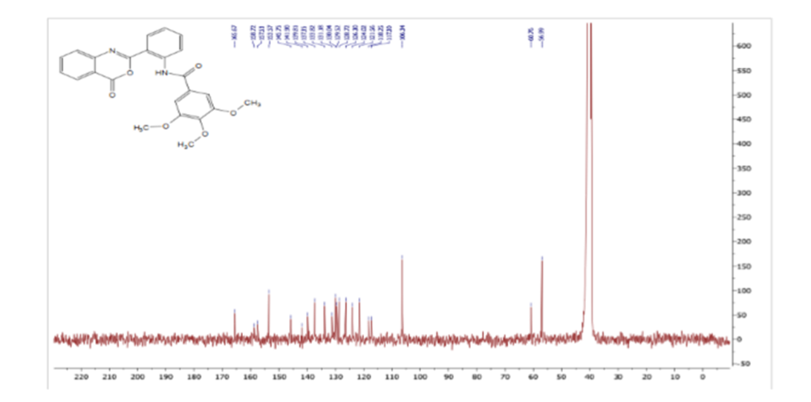

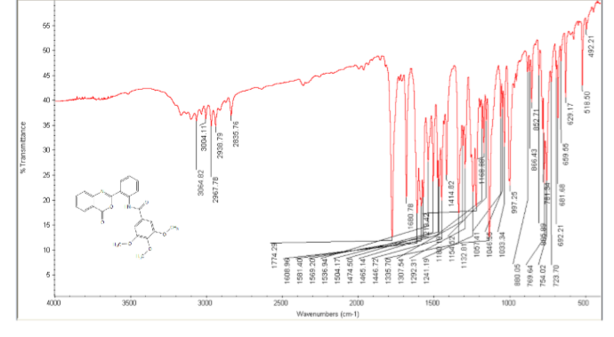
Figure S73 FT-IR spectrum of 6k

Figure S74 ¹H NMR spectrum of 6l
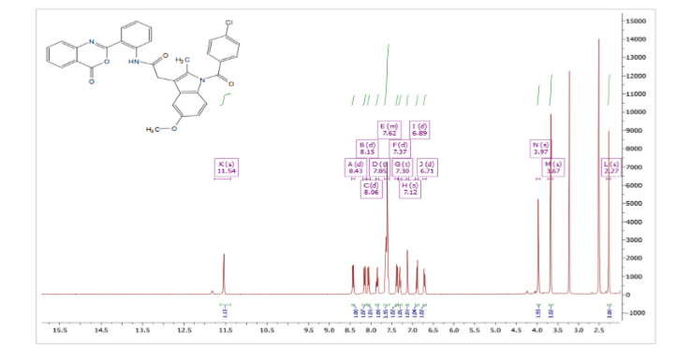

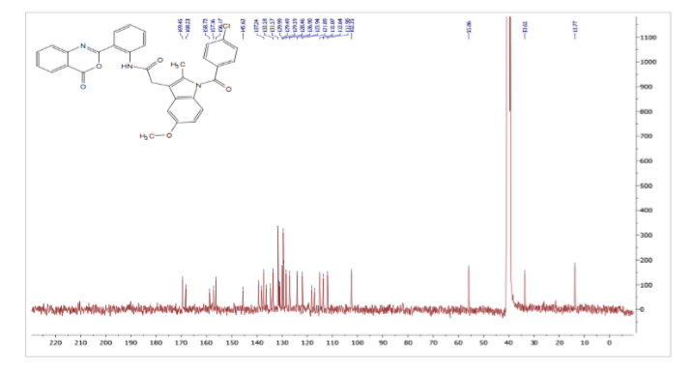
Figure S75 ¹³CNMR spectrum of 6l

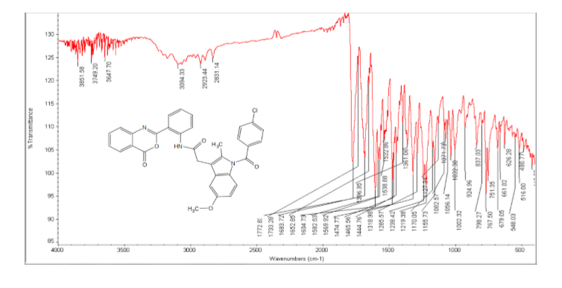
Figure S76 FT-IR spectrum of 6l

Figure S77 ¹H NMR spectrum of 6m
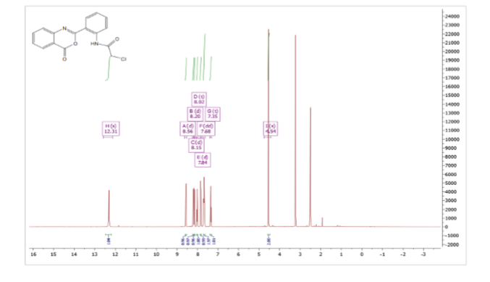
Figure S78 ¹³CNMR spectrum of 6m
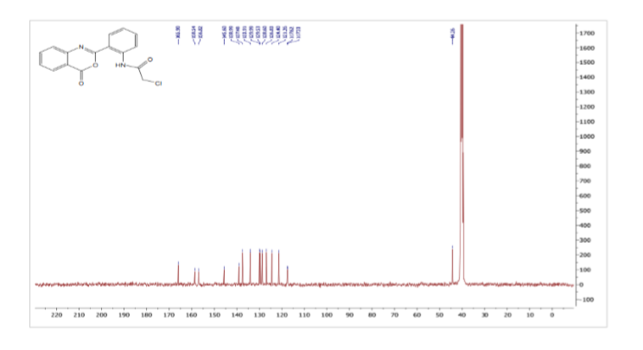

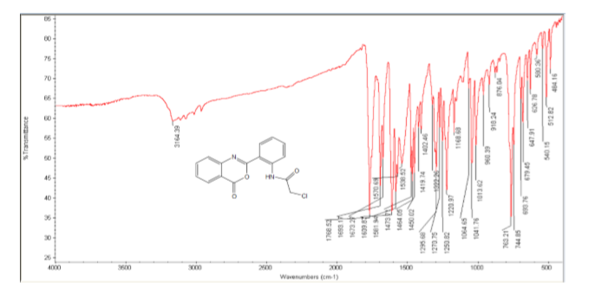
Figure S79 FT-IR spectrum of 6m

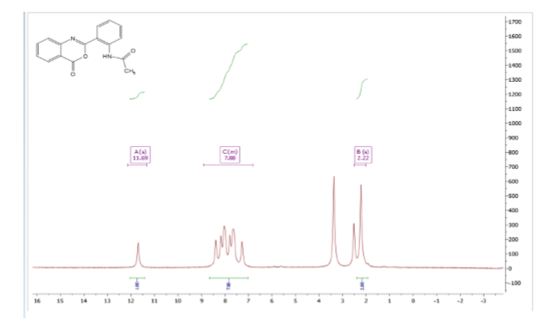
Figure S80 ¹H NMR spectrum of 6n

Figure S81¹³CNMR spectrum of 6n
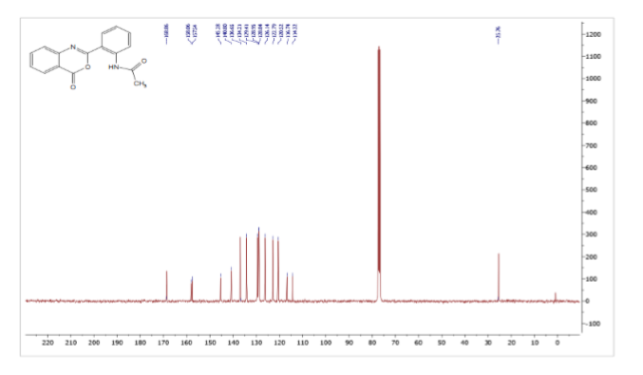

Enzymatic HIV-1 RTI Assay S1. ²⁰
Recombinant HIV-1-RT (4–6 ng) diluted in lysis buffer (20 µL per well) was used. In a separate reaction, lysis buffer with no HIV-1-RT was used as a negative control. Then, 20 µL of RT inhibitor diluted in lysis buffer was incubated with 20 µL of reaction mixture per reaction tube for 1 h at 37 °C. Sufficient foil bags for the number of MP modules were opened and used. The MP modules are then put into the frame in the correct orientation. MP modules were deemed as ready to be used and did not need to be rehydrated prior to the addition of the samples. The samples (60 µL) were transferred into the wells of the MP modules and covered with a cover foil before being incubated for 1 h at 37 °C. The solution was then completely removed before each well was rinsed five times with 250 µL of washing buffer for 30 s, which was then carefully removed. Diluted anti-IG-POD (200 µL, 200 Mu/mL) was added to each well; then, the MP modules were covered with a cover foil and incubated for 1 h at 37 °C. The solution was then completely removed, and each well was rinsed five times using 250 µL of washing buffer for 30 s, which was then carefully removed. ABTS substrate solution (200 µL) was added to each well, which was then incubated at +15 °C to +25 °C until the color of the solutions (green color) was sufficient for photometric detection (10–30 min). The absorbance of the samples was measured using a microplate (ELISA) reader, at 450 nm (reference wavelength of approximately 490 nm).

Cytotoxicity Evaluation, CE S2²¹
Assay Procedure- was carried out using viability assay. For cytotoxicity assay, the cells were seeded in a 96-well plate at a cell concentration of 1 × 10⁴ cells per well in 100 µL of growth medium. A fresh medium containing different concentrations of the test sample was added after 24 h of seeding. Serial twofold dilutions of the tested chemical compounds were added to confluent cell monolayers dispensed into 96-well, flat-bottomed microtiter plates (Falcon, NJ, USA) using a multichannel pipette. The microtiter plates were incubated at 37 °C in a humidified incubator with 5% CO₂ for a period of 24 h. Three wells were used for each concentration of the test sample. Control cells were incubated without a test sample and with or without dimethyl sulfoxide (DMSO). The small percentage of DMSO present in the wells (maximum of 0.1%) was found not to affect the experiment. After incubation of the cells at 37 °C for 24 h, the viable cell yield was determined using a colorimetric method.
In brief, after the end of the incubation period, the solvent media were aspirated and crystal violet solution (1%) was added to each well for at least 30 min. The stain was removed, and the plates were rinsed using tap water until all excess stain was removed. Glacial acetic acid (30%) was then added to all of the wells and mixed in thoroughly, and then, the absorbance of the plates was measured after gentle shaking on a microplate reader (TECAN, Inc.) at a test wavelength of 490 nm. All results were corrected for background absorbance detected in wells without added stain. Treated samples were compared with the cell control in the absence of the tested compounds. All experiments were carried out in triplicate. The cell cytotoxicity effects of each tested compound were calculated. The optical density was measured using a microplate reader (Sunrise, TECAN, Inc., USA) to determine the number of viable cells, and the percentage of viability was calculated using [(OD_{t}/OD_{c})] × 100%, where OD_{t} is the mean optical density of wells treated with the test samples and OD_{c} is the mean optical density of untreated cells. The relationship between the surviving cells and drug concentration was plotted to obtain the survival curve of each tumor cell line after treatment with the specified compound. The 50% inhibitory concentration (IC₅₀), the concentration required to cause toxic effects in 50% of intact cells, was estimated from plots of the dose-response curve for each concentration using GraphPad Prism software (San Diego, CA, USA).
==================================================================

